Year 3 – Autumn 1 – Seeds and Berries
Key Words | Definitions
air | The mixture of gases which forms the Earth’s atmosphere
crumble | A baked dessert of fruit topped with  a crumbly pastry mixture.
light | The natural agent that stimulates sight and makes things visible.
life cycle | The series of changes in the life of an organism.
transport | Take something from one place to another.
soil | The upper layer of earth in which plants grow.
seasonal | Relating to a particular season of the year.
trunk | The main woody stem of a tree.
What is seed dispersal?
Seed dispersal is the movement or transport of seeds away from the parent plant. This helps plants to grow and survive in new places.

Images
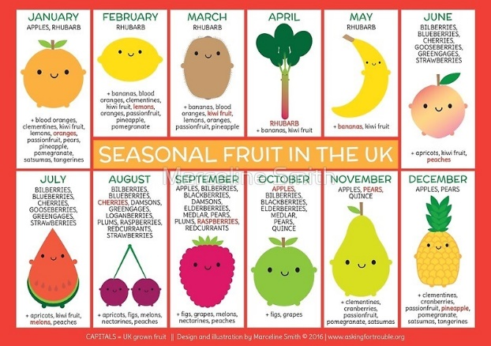
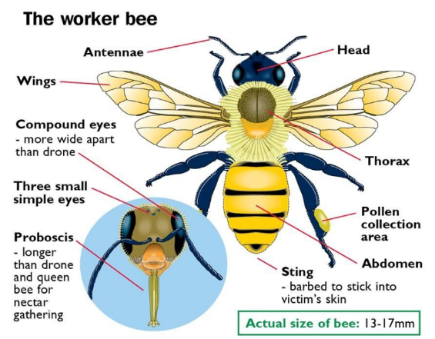

Important figures
Horticulturalists
Edith, Lady Londonderry | Luther Burbank | Alan Titchmarsh
1878-1959  Edith was a visionary garden designer and a suffragette. She created one of the most original gardens of the 20th century at Mount Stewart in County Down, Northern Ireland.  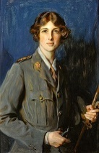 | 1849-1926  Burbank focused on crossbreeding plants to improve their quality, coming up with a superior potato. He developed over 800 new types of plants in his 55-year career.  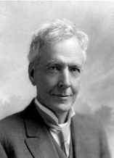 | 1949-present  Alan, who was born in Ilkley, Bradford, is a gardener, broadcaster, TV presenter, poet, and novelist. He is a professional gardener, a gardening journalist and appears on television gardening programmes.  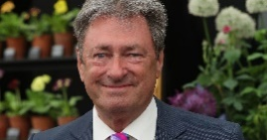

Monday | Tuesday | Wednesday | Thursday | Friday
HWK – Spelling | HWK – Weekly Skills | HWK – Maths book | HWK – Grammar Book | HWK – Reading  PE - All
Key Dates:
- Week 1 – Community Forest days
- Berry Picking and Seed Dispersal Forest days – date to be confirmed - Story in the Woods Forest day – date to be confirmed

