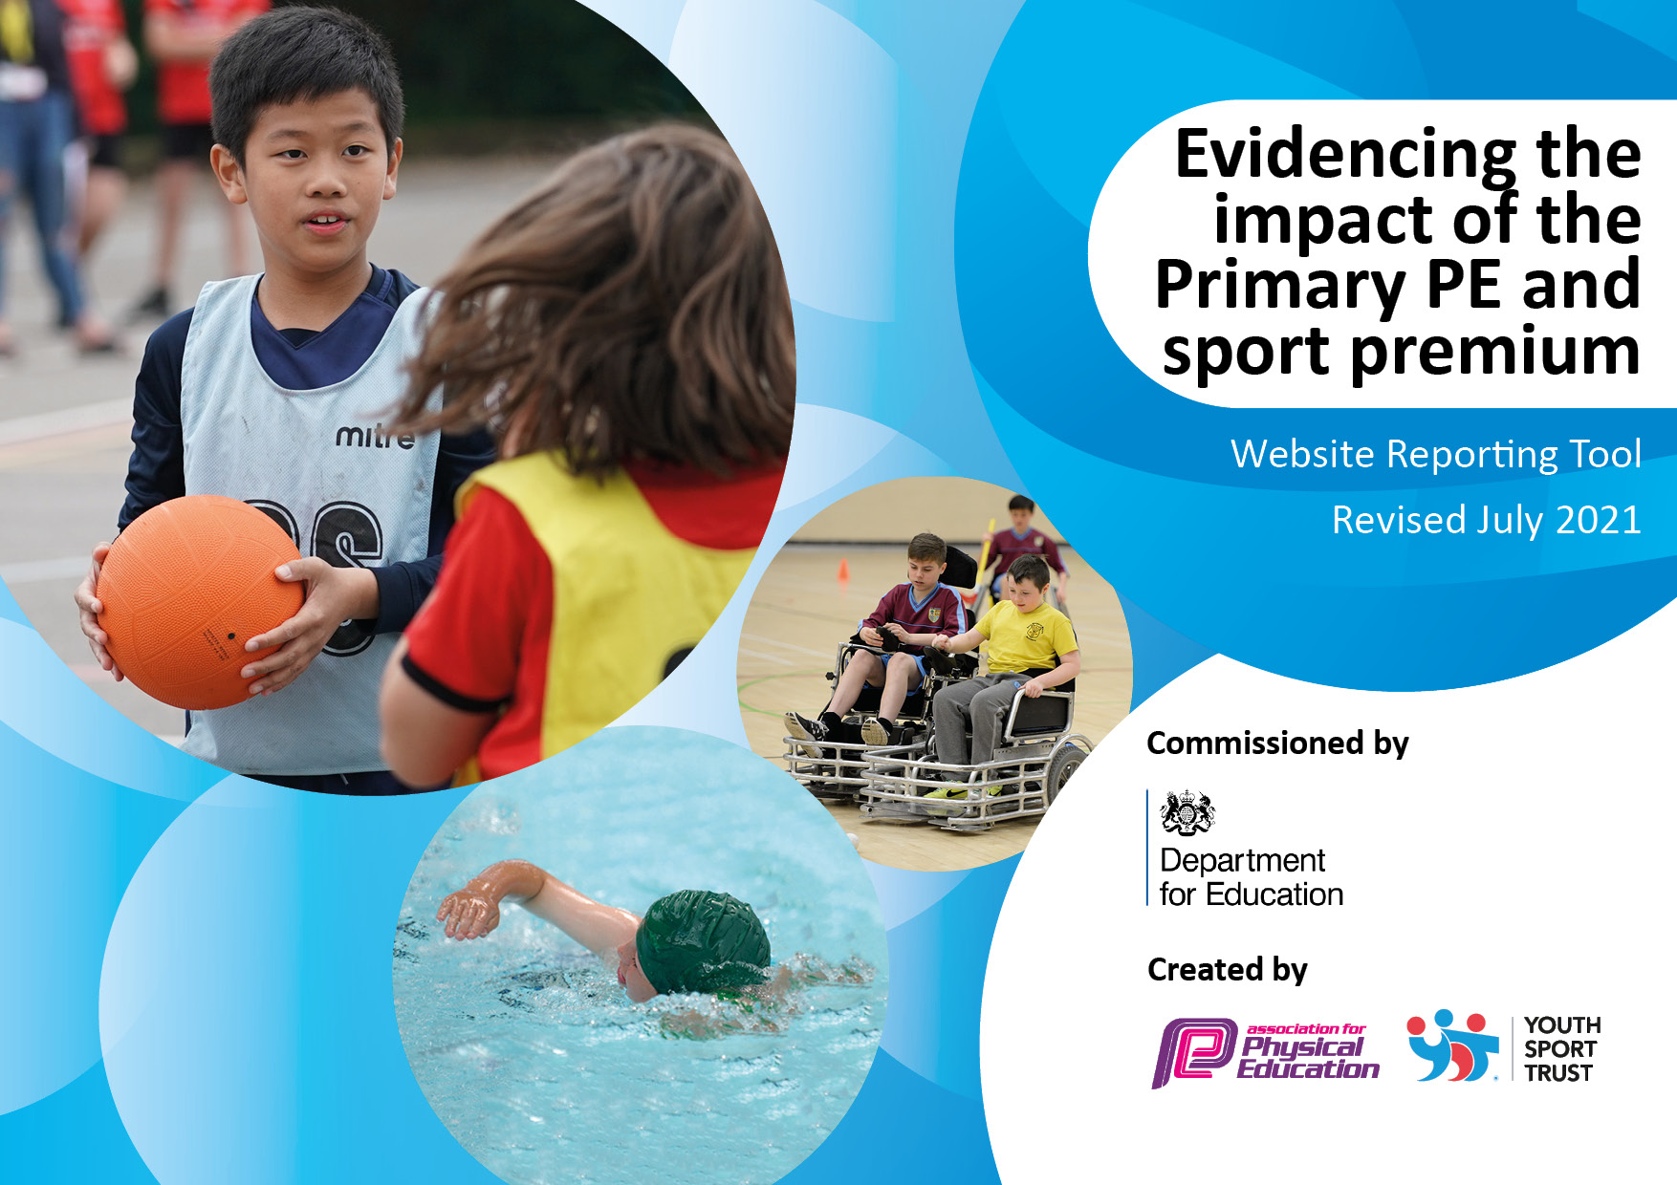
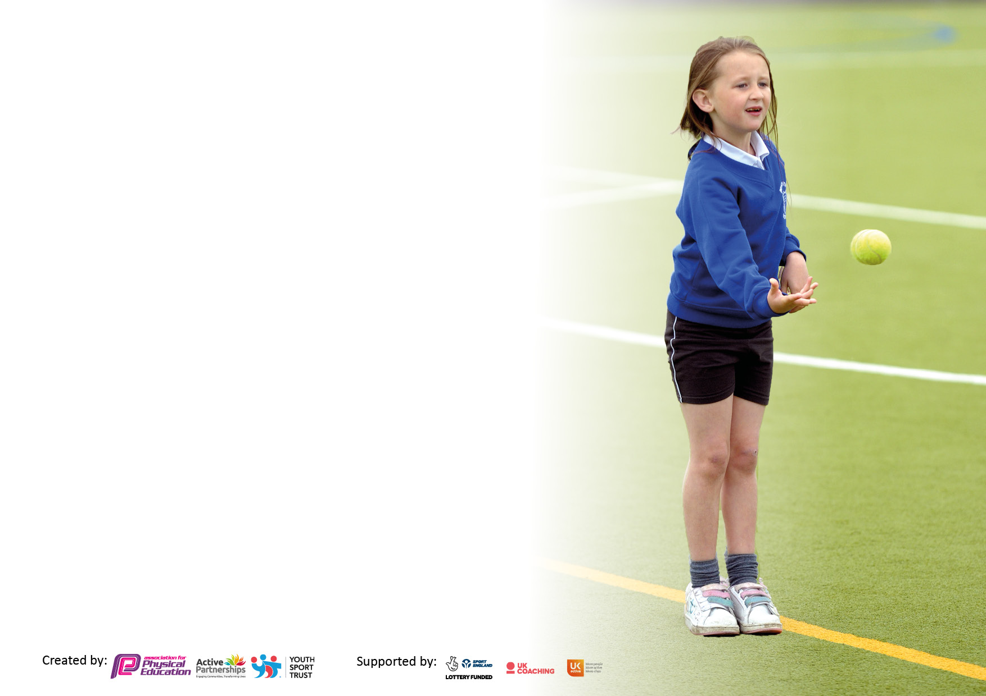

It is important that your grant is used effectively and based on school need. The Education Inspection Framework makes clear there will be a focus on ‘whether leaders and those responsible for governors all understand their respective roles and perform these in a way that enhances the effectiveness of the school’.

Under the Quality of Education Ofsted inspectors consider:
Intent - Curriculum design, coverage and appropriateness
Implementation - Curriculum delivery, Teaching (pedagogy) and Assessment
Impact - Attainment and progress

To assist schools with common transferable language this template has been developed to utilise the same three headings which should make your plans easily transferable between working documents.

Schools must use the funding to make additional and sustainable improvements to the quality of Physical Education, School Sport and Physical Activity (PESSPA) they offer. This means that you should use the Primary PE and sport premium to:
- Develop or add to the PESSPA activities that your school already offer
- Build capacity and capability within the school to ensure that improvements made now will benefit pupils joining the school in future years
- The Primary PE and sport premium should not be used to fund capital spend projects; the school’s budget should fund these.

Please visit gov.ukfor the revised DfE guidance including the 5 key indicators across which schools should demonstrate an improvement.This documentwillhelpyoutoreviewyourprovisionandtoreportyourspend.DfEencouragesschools to use this template as an effective way of meeting the reporting requirements of the Primary PE and sport premium.

We recommend you start by reflecting on the impact of current provision and reviewing the previous spend.

Schools are required to publish details of how they spend this funding, including any under-spend from 2019/2020, as well as on the impact it has on pupils’ PE and sport participation and attainment. All funding must be spent by 31st July 2022.

Created by: L. Burgin Supported by: Z. Mawson

Details with regard to funding
Please complete the table below.

Total amount carried over from 2020/21 | £0
Total amount allocated for 2021/22 | £21420
How much (if any) do you intend to carry over from this total fund into 2022/23? | £0
Total amount allocated for 2022/23 | £21380
Total amount of funding for 2022/23. To be spent and reported on by 31st July 2023. | £21380
Swimming Data
Please report on your Swimming Data below.

Meeting national curriculum requirements for swimming and water safety.  N.B. Complete this section to your best ability. For example you might have practised safe self-rescue techniques on dry land which you can then transfer to the pool when school swimming restarts.  Due to exceptional circumstances priority should be given to ensuring that pupils can perform safe self rescue even if they do not fully meet the first two requirements of the NC programme of study | We provide weekly swimming lessons that are in line with the National Curriculum through the swimming programme offered by our LEA at the local swimming pool.
What percentage of your current Year 6 cohort swim competently, confidently and proficiently over a distance of at least 25 metres?  N.B. Even though your pupils may swim in another year please report on their attainment on leaving primary school at the end of the summer term 2022.  Please see note above | 21%
What percentage of your current Year 6 cohort use a range of strokes effectively [for example, front crawl, backstroke and breaststroke]?  Please see note above | 7%
What percentage of your current Year 6 cohort perform safe self-rescue in different water-based situations? | 10%
Schools can choose to use the Primary PE and sport premium to provide additional provision for swimming but this must be for activity over and above the national curriculum requirements. Have you used it in this way? | Yes/No

Action Plan and Budget Tracking
Capture your intended annual spend against the 5 key indicators. Clarify the success criteria and evidence of impact that you intend to measure to evaluate for pupils today and for the future.

Academic Year: 2022/23 | Total fund allocated: £21380 | Date Updated:
Key indicator 1: The engagement of all pupils in regular physical activity – Chief Medical Officers guidelines recommend that primary school pupils undertake at least 30 minutes of physical activity a day in school |  |  |  | Percentage of total allocation:
 |  |  |  | %
Intent | Implementation |  | Impact | Sustainability and suggested next steps:
Provide structured/adult led activities to engage less active children in physical activity during lunchtime. Children know about a range of sports and playground games that they can engage with. | - Sports coaches employed on KS1 and KS2 playgrounds leading a range of sports activities and playground games.  - Leaders have lunch duties to model and monitor playground activities.  - Continuation of OPAL (Outdoor Play and Learning) programme that was launched last year.  - Purchase of high-quality playtime equipment that promotes activity.  - KS2 sports leaders running activities on KS1 playground. | Funding allocated:  £12,870 | We now offer a range of playground activities, not just sports for children to engage in.  Activity for all has increased. | OPAL has been added to the wider curriculum lead’s responsibilities.  Children’s engagement with activities on offer to be monitored.
Key indicator 2: The profile of PESSPA being raised across the school as a tool for whole school improvement |  |  |  | Percentage of total allocation:
 |  |  |  | %
Intent | Implementation |  | Impact | Sustainability and suggested next steps:
School leaders to have an overview of the PE and sport curriculum. | - DHT and wider curriculum lead to monitor PE curriculum.  - DHT to meet with lead sports coach each half term to quality assure PE delivered in PPA. | Funding allocated:£0 | School leaders have a good oversight of the PE and Sport curriculum. The strengths and areas to develop are well established. | Quality assurance processes to be built into the DHTs and wider curriculum leads roles and responsibilities.
Whole school outdoor play and learning initiative to improve and raise the profile of outdoor play and learning. | - Continue OPAL programme  - EYFS provision CPD  - Forest school sessions embedded within the curriculum.  - Sports week with parent spectators.  - Leaders present on playground during lunchtimes.  - Support staff CPD regarding outdoor play and learning. | £0 | Profile of outdoor play and learning has been raised. Staff at all levels, from support staff to school leaders are involved in outdoor play and learning. | CPD schedule for support staff to build in time to revisit OPAL training.  Playground duties to continue to form part of leaders roles and responsibilities.

Key indicator 3: Increased confidence, knowledge and skills of all staff in teaching PE and sport |  |  |  | Percentage of total allocation:
 |  |  |  | %
Intent | Implementation |  | Impact | Sustainability and suggested next steps:
Staff delivering PE will have access to high quality PE planning in order to increase their confidence, knowledge and skills in teaching PE and sport. | Little Sports Company PE planning used in PPA by sports coaches and in PE lessons by teachers.  PE lessons to follow on from what is taught in PPA lessons to enable sports coaches to provide modelling and guidance on the planning and delivery as required.  DHT, wider curriculum lead and sports coach lead to observe PPA and PE lessons, providing feedback to staff. | £0 | Teaching of PE and sport is consistent whether delivered by teachers or sports coaches. | Planning is accessible to all staff in staff SharePoint learning resources area.
Key indicator 4: Broader experience of a range of sports and activities offered to all pupils |  |  |  | Percentage of total allocation:
Intent | Implementation |  | Impact | Sustainability and suggested next steps:
A range of sports clubs will be offered across school. | Basketball breakfast club introduced for Y5/6.  After school sports clubs include a wider range of sports. | £7722 | A wider variety of sports and activities are now offered. | Develop a club strategy that includes sports and ensures activities are not just offered to all but accessed by all.

Key indicator 5: Increased participation in competitive sport |  |  |  | Percentage of total allocation:
 |  |  |  | %
Intent | Implementation |  | Impact | Sustainability and suggested next steps:
Increase participation in competitive sport to pre-covid levels. | LSC sports coaches and learning mentor to organise attendance at trust, cluster and local area sports competitions.  Competitions matched to clubs to increase pupil confidence at competitions. | Funding allocated:  £788 | Targetted children are now attending participating in competitive sporting opportunities. | Include competitive sport opportunities in the club strategy that will be developed.

Signed off by
Head Teacher: | Zoe Mawson
Date: | 19.12.22
Subject Leader: | Laura Burgin
Date: | 19.12.22
Governor: | Salma Younis
Date: | 19.12.22

