Year 2 – Autumn 1 – World Explorers
Key Words | Definitions
atlas | A book that shows a variety of different maps.
compass | 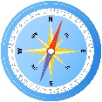  A tool for finding direction.
continent | A continuous expanse of land, there are 7 in total.
country | A nation with its own government occupying a particular territory.
Earth | The planet we live on.
equator | An imaginary line around the ‘middle’ of the Earth.
globe | 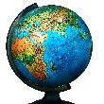  A model of our Earth showing the continents and oceans.
map | A representation of an area of land or sea showing physical features.
North Pole | A very cold place at the ‘top’ of the Earth.
ocean | A very large area of water.
South Pole | A very cold place at the ‘bottom’ of the Earth.
What is an explorer?
An explorer is someone who travels to places about which very little is known, in order to discover what is there.

Maps
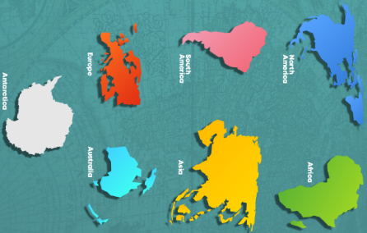

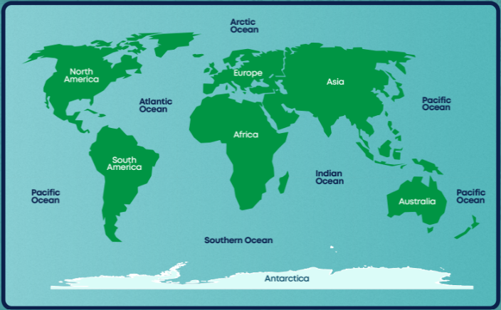

Important figures
World Explorers
Sir Francis Drake | Matthew Henson | Sarah Outen
1540-1596  He was an English sailor and navigator who was the first person to sail around the globe. He brought back treasures for Queen Elizabeth I. Some say he was a hero; some say he was a villain.  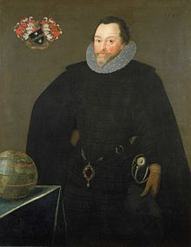 | 1866-1955  He was a black African American explorer.  He may have been the first person to stand on the North Pole in 1909.  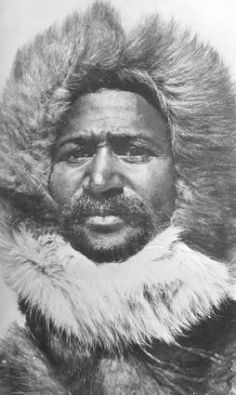 | 1985-present  She is a British athlete and adventurer. She is the first woman and the youngest person to row solo across the Indian and Pacific Ocean.  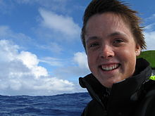

Monday | Tuesday | Wednesday | Thursday | Friday
HWK - Numbots and Spelling Shed – 10mins each  Reading | HWK - Numbots and Spelling Shed – 10mins each  Reading | HWK - Numbots and Spelling Shed – 10mins each  Reading | HWK - Numbots and Spelling Shed – 10mins each, Reading  Year 2 PE | HWK - Maths Homework Book  Numbots and Spelling Shed – 10mins each  Reading
Key Dates:
- Week 1 – Community Forest days

