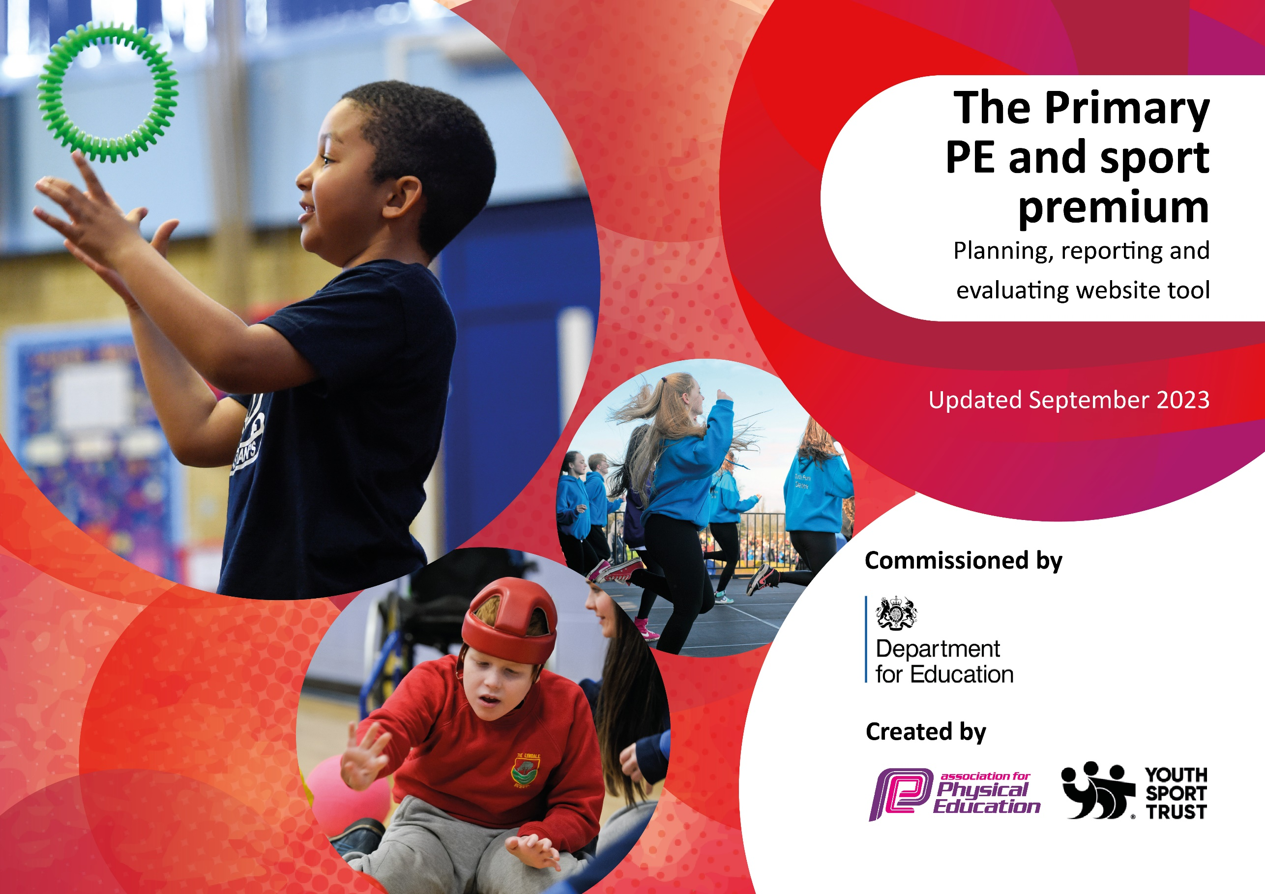

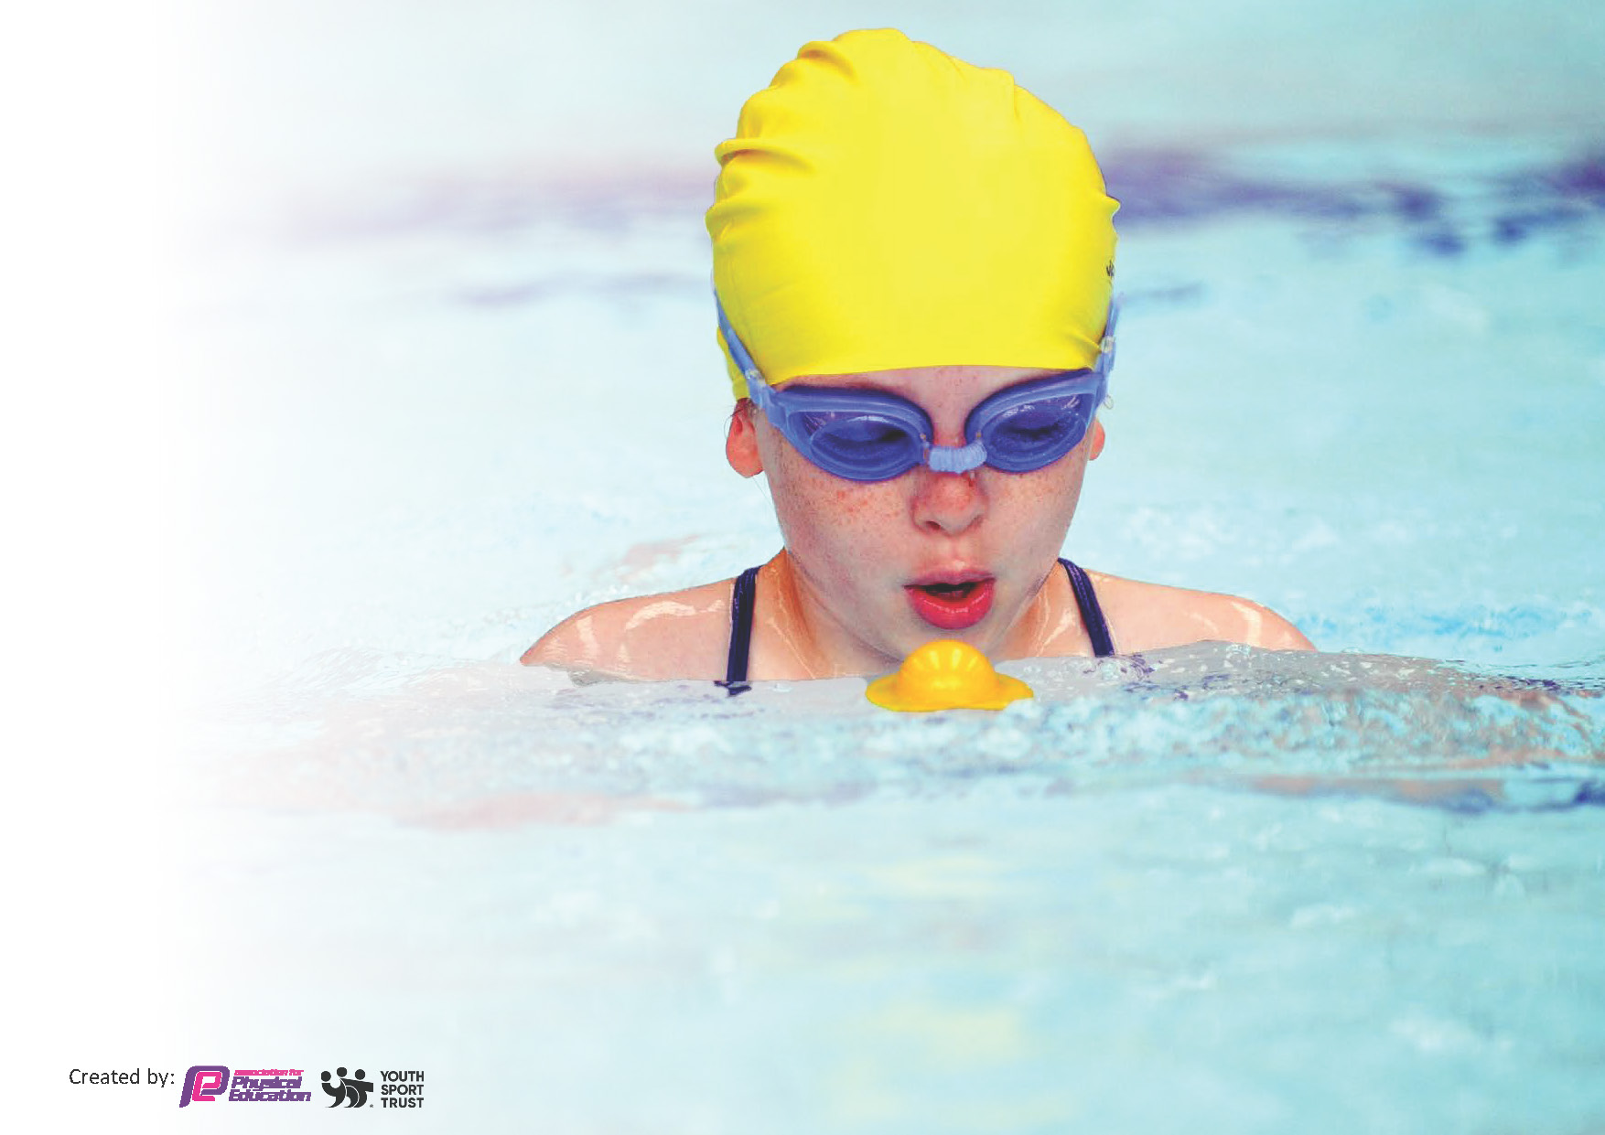
This template can be used for multiple purposes:
by:
- It enables schools to effectively plan their use of the Primary PE and sport premium
- It helps schools to meet the requirements (as set out in guidance) to publish information on their Primary PE and sport premium
- It will be an effective document to support Ofsted inspections enabling schools to evidence progress in Physical Education (PE) and evidence swimming attainment, which forms part of the PE National Curriculum. We would recommend schools consider
the Intent, Implementation and Impact of any spend, as examined within the Education Inspection Framework.

It is important that your grant is used effectively and based on school need.

Schools must use the funding to make additional and sustainable
improvements to the quality of the PE, School Sport and Physical Activity (PESSPA)
they offer. This means that you should use the Primary PE and sport premium to:

- Build capacity and capability within the school to ensure that improvements made now will benefit pupils joining the school in future years
- Develop or add to the PESSPA activities that your school already offers.

The Primary PE and sport premium should not be used to fund capital spend projects; the school’s core budget should fund these. Further detail on capital expenditure can be found in the updated Primary PE and sport premium guidance.

The Primary PE and sport premium guidance, outlines 5 key priorities that funding should be used towards. It is not necessary that spending has to meet all the key priorities, you should select the priorities that you aim to use any funding towards.
Although completing this template is not a requirement for schools, schools are required to publish details of how they spend this funding. Schools must also outline what the impact this funding has had on pupils’ PE and sport participation and attainment and how any spending will be sustainable in the future. All funding must be spent by 31st July 2024.
The Department for Education has worked closely with the Association for Physical Education (afPE) and the Youth Sport Trust (YST) to develop this template and encourages schools to use it. This template is an effective way of meeting the reporting requirements of the Primary PE and sport premium.

Review of last year’s spend and key achievements (2022/2023)
We recommend you start by reflecting on the impact of current provision and reviewing your previous spend.
Activity/Action  Increase pupils’ engagement in regular physical activity through more active playtimes.  Provide planning and support for delivery of high-quality PE and sport.  Offer a range of out of school hours sports clubs.  Increase participation in competitive sport to pre-covid levels. | Impact  The range of sports and play activities has increased due to the role of sports coaches, OPAL training for teachers and TAs and pupil play leaders.  Little Sports Coach (LSC) company planning has been shared and reviewed throughout the year by year leaders, which has increased discussions around quality PE planning.  The range of sports on offer has increased.  Targeted children participated in inter school competitions. | Comments  The playground needs to be reviewed so that more of the space is utilized and that children have free flow of the space. Leadership capacity to be directed to this area of development 23-24.  LSC planning gave a clear overview but some plans needed more detail to support effective delivery. Leadership capacity to be directed to this area of development 24-25.  A system needs to be introduced to ensure that all children can access extra-curricular clubs 23-24.  Previous inter-school competition links have not been able to be maintained. Further links to be explored. Leadership capacity to be directed to this area of development 24-25.

Key priorities and Planning
This planning template will allow schools to accurately plan their spending.

Action – what are you planning to do | Who does this action impact? | Key indicator to meet | Impacts and how sustainability will be achieved? | Cost linked to the action
Enable free flow between our two playgrounds and offer an increased range of both adult and child-led activities.  Provide club opportunities for all children in KS1 and KS2.  Develop the intent and implementation of Creating Active Schools. | Curriculum leaders - to design the intent and implementation of our playground offer.  TAs, lunchtime supervisors, teaching staff and sports coaches - to set up and lead/oversee the activity pupils take part in.  Curriculum leader - to design the intent and implementation of our clubs offer.  Creating Active Schools leader to design the intent and implementations of Creating Active Schools.  Teachers – to have the knowledge and skills to bring activity into learning. | Key indicator 2: The engagement of all pupils in regular physical activity.  Key indicator 4: Broader experience of a range of sports and activities offered to all pupils.  Key indicator 2: The engagement of all pupils in regular physical activity.  Key indicator 4: The profile of PESSPA being raised across the school as a tool for whole school improvement. | More pupils meeting their daily physical activity goal.  More pupils taking part in sport activities.  More pupils meeting their daily physical activity goal.  School leaders have a good oversight of the PE and Sport curriculum. The strengths and areas to develop are well established. | £3762  Cost for sports coaches to support lunchtime sessions.  £6626  For playtime resources.  £10,032  Cost for sports coaches to run sessions during the school day as well as before and after school.  £1000  Cost for CAS lead to attend training sessions.

Key achievements 2023-2024
This template will be completed at the end of the academic year and will showcase the key achievements schools have made with their Primary PE and sport premium spending.

Activity/Action | Impact | Comments

Swimming Data
Meeting National Curriculum requirements for swimming and water safety.
Priority should always be given to ensuring that pupils can perform safe self-rescue even if they do not fully meet the first two requirements of the National Curriculum programme of study

Question | Stats: | Further context  Relative to local challenges
What percentage of your current Year 6 cohort can swim competently, confidently and proficiently over a distance of at least 25 metres? | 6% | Most of the children who attend our school have no experience of swimming outside of school lessons. Due to the impact of covid this cohort only accessed weekly swimming lessons for part of the year rather than weekly for the whole year.  We have now moved to daily on-site lessons for a half term which has dramatically improved our swimming outcomes, which will be seen in future Year 6 cohorts.
What percentage of your current Year 6 cohort can use a range of strokes effectively [for example, front crawl, backstroke, and breaststroke]? | 3% | As above.

What percentage of your current Year 6 cohort are able to perform safe self-rescue in different water-based situations? | 3% | As above.
If your schools swimming data is below national expectation, you can choose to use the Primary PE and sport premium to provide additional top-up sessions for those pupils that did not meet National Curriculum  requirements after the completion of core lessons. Have you done this? | Yes/No | The local swimming pool that we were using did not provide additional top-up lessons. We have now moved to using a temporary ‘pop up’ swimming pool that is located on the school site for half a term. This has allowed us to offer top up sessions for any children that did not achieve the swimming National Curriculum and will impact future Year 6 data.
Have you provided CPD to improve the knowledge and confidence of staff to be able to teach swimming and water safety? | Yes/No | We have used local authority swimming teachers and have now moved to a private company to provide swimming lessons on site.

Signed off by: L.Burgin

Head Teacher: | Zoe Mawson
Subject Leader or the individual responsible for the Primary PE and sport premium: | Laura Burgin
Governor: | Salma Younis
Date: | 08/01/24

