3 Year Nursery – Autumn 1 – All about me
Key Words | Definitions
happy | 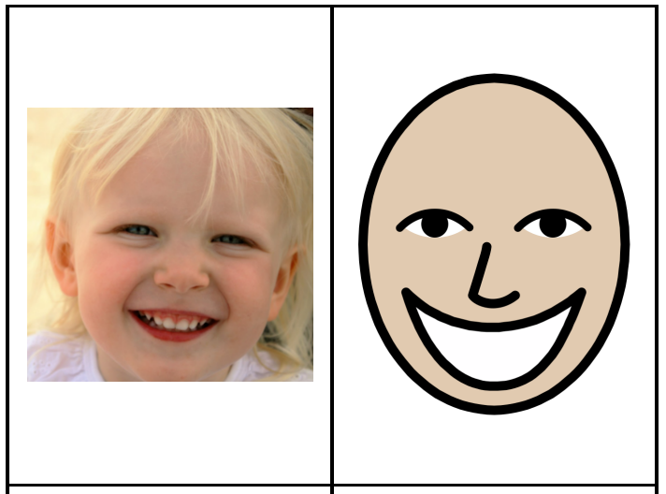
sad | 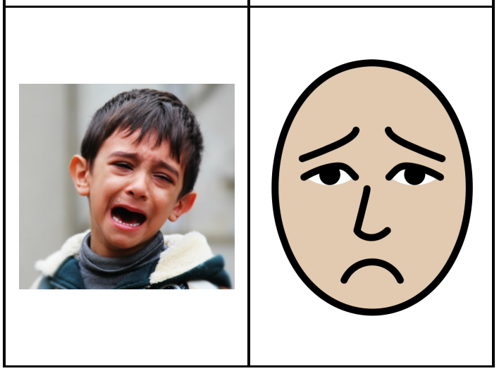
angry | 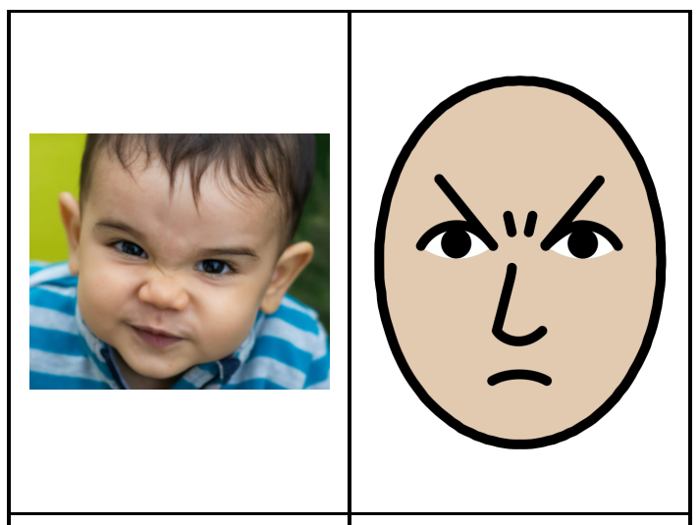
excited | 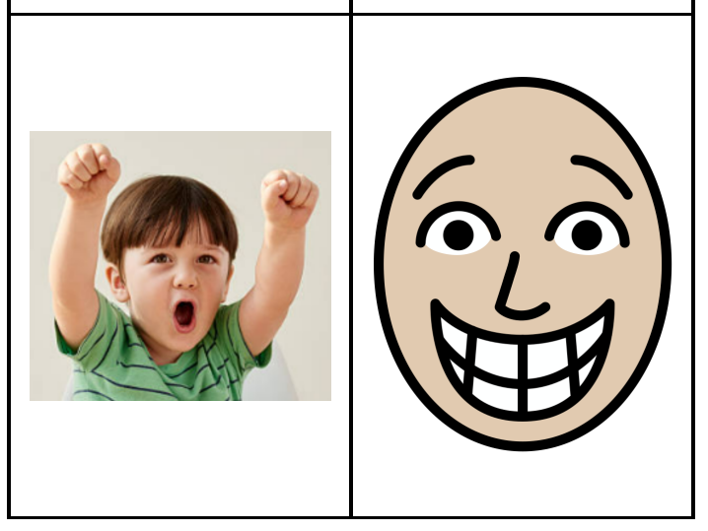
scared | 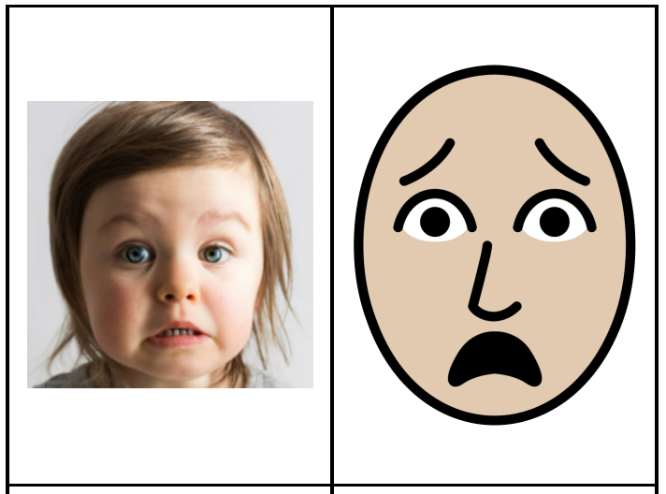
tired | 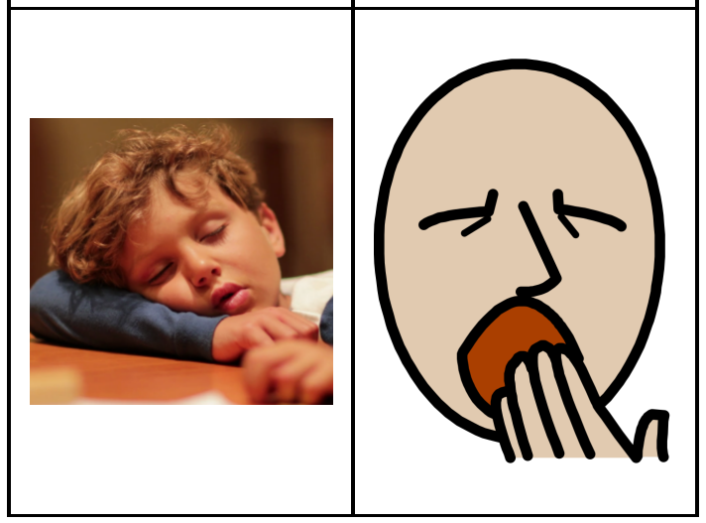
What is a feeling? How might my body react?
Feelings are emotions you will feel all the time. If you are playing with your favourite toy you may feel happy. Our bodies react differently to feelings. If you feel sad, you may have tears coming from your eyes. If you are happy, you may have a smile on your face.

Nursery Rhymes
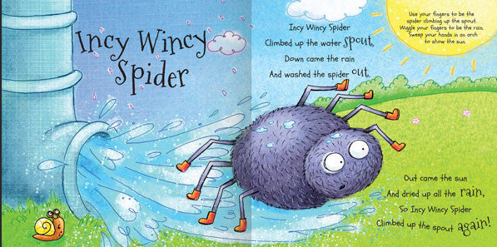  Join in with the nursery rhyme Incy Wincy Spider. Scan the QR code. | 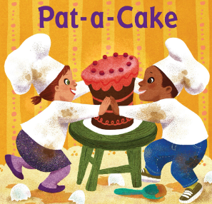  Join in with the nursery rhyme Pat-a-cake. Scan the QR code. | 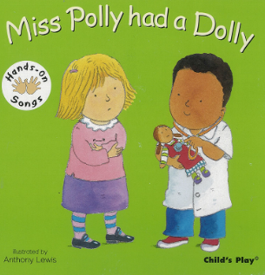  Join in with the nursery rhyme Miss Polly. Scan the QR code.

Important figures
School nurse | Doctor
Jess | Dr Ranj
Jess is our school nurse. She helps people if they hurt themselves or if they have allergies. | Dr Ranj is a doctor who helps people when they feel unwell.

Monday | Tuesday | Wednesday | Thursday | Friday
Read with your child and sign their diary | Read with your child and sign their diary | Read with your child and sign their diary | Read with your child and sign their diary | Read with your child and sign their diary
Key Dates:
- Every Monday from 25th September 3 Year Nursery will visit the woodlands.
Please ensure your child has a pair of wellies with their name on in nursery and a suitable outdoor coat.

