**Brown Bear Brown Bear?** Brown Bear Brown Bear What Do You See?’

Can you practice naming the colours?

Can you practice naming the animals?

** 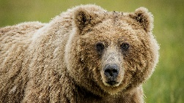

brown bear

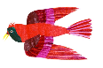 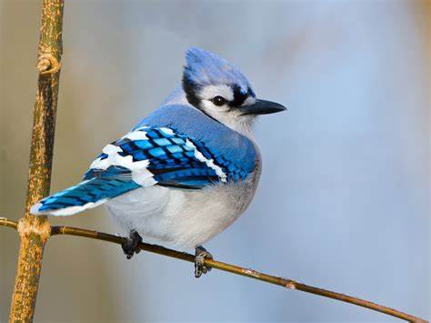

red bird

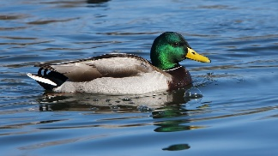

yellow duck

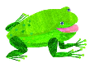 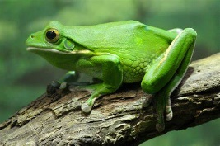

green frog

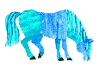 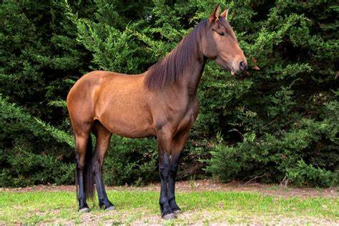

blue horse

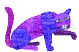 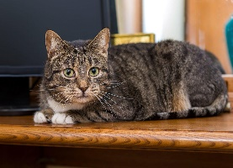

purple cat

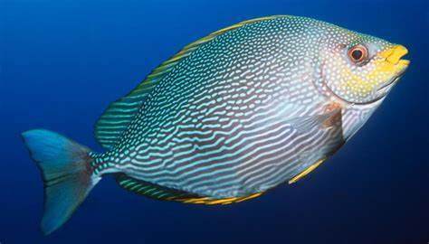

gold fish

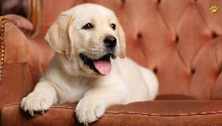

white dog

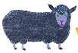 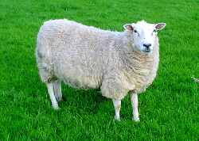

black sheep