The Struggle for England- Anglo-Saxons and Vikings Family Fact Sheet – Year 5
In Literacy we will use the suspense toolkit to write an overcoming a monster tale.
Key Vocabulary | Definitions
Germanic | Come from Germany.
Angles | The Angles were one of the main Germanic peoples who settled in Great Britain in the post-Roman period.
Picts | One of an ancient people who lived in what is now eastern and North-Eastern Scotland
Jutes | The Jutes were one of the Germanic tribes who settled in Great Britain after the departure of the Romans.
Scots | People native to Scotland.
Saxons | The Saxons were a group of Germanic peoples.
runes | Runes are the letters in a set of related alphabets known as runic alphabets native to the Germanic peoples.
invasion | A large group of people entering a new place, usually with an army and by force.
settlement | A place where people settled.
migration | Movement from one place to another.
Who were the Anglo-Saxons?  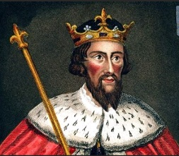  How were the old kingdoms united and the first monarch crowned? | The Anglo-Saxons were a mixture of different tribes who came from north Germany, Denmark, and the northern Netherlands. They sailed across the North Sea and arrived in Britain after the Romans left in 410CE.  The Anglo-Saxons had different kings who ruled their own kingdoms. After years of fighting, Alfred the Great and the Vikings made a peace agreement, however they did still fight. They created an imaginary dividing line through England with the Anglo-Saxons to the West and the Viking lands (Danelaw) to the East.
What was life like for and Anglo- Saxons?  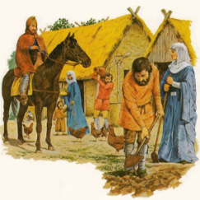 | Agriculture – Anglo-Saxons and Vikings were farmers and kept animals and grew crops. They were also craft workers who made objects from wood and metal.  Family Life- Anglo-Saxon houses were made from wood with a thatched roofs and had only one room where everyone ate, cooked, slept and entertained their friends.  Beliefs - Anglo-Saxons and Vikings were pagans. They believed in many gods who were in charge if different parts of life.
Why did Anglo-Saxons come to Britain?  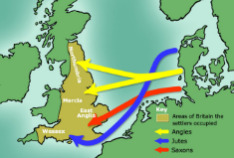 | The Anglo-Saxons came to Britain to invade, then they settled here, hoping for a better life. They came from Germany, Denmark and the Netherlands and settled in Angle-land or England. The Vikings came from Scandinavia (the countries Denmark, Norway and Sweden).

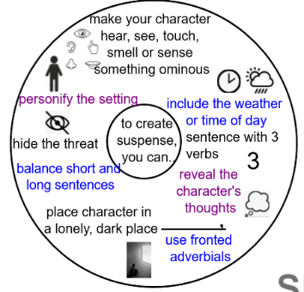

Scan the code to check out the route we will take to Bramhope.

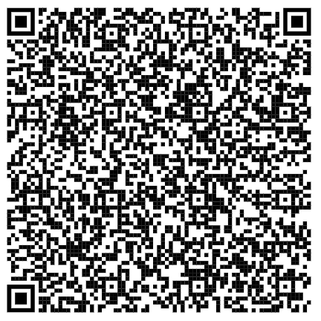

Trip Dates – Autumn 2
Thursday 3rd – Friday 4th November – Myrtle Bramhope
Thursday 10th – Friday 11th November – Maple Bramhope
Thursday 17th – Friday 18th November – Magnolia Bramhope
Thursday 1st December – Hindu Temple Visit (In school hours)

PE Days
Monday and Wednesday
Homework
Grammar – Tuesday (due the following Tuesday)
Maths – Thursday (due the following Thursday)
Spellings – Monday (Test on Friday)
Key Dates – Autumn 2
Tuesday 1st November – GLEE reading workshop 8.45 – 9.30
Monday 14th November - anti-bullying week
Friday 18th November – Children in Need
Friday 25th November – Staff Training Day
Friday 16th December – Reports go home

