Year 5 – Autumn 1 – Natural Disasters
Key Words | Definitions
earthquake | A sudden violent shaking of the ground.
natural disaster | Natural processes in the atmosphere, ocean or land that causes great damage.
plate boundary | Where two tectonic plates meet.
seismic | Relates to the movements within the Earth’s crust.
tectonic plate | Large piece of the Earth’s crust.
tsunami | A huge flood of sea water caused most often by an underwater earthquake.
volcano | A place where lava, pieces of rock or gas are or have been erupted from under the Earth’s crust.

Where in the world are most of the volcanoes and earthquakes?
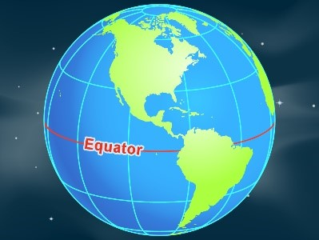  The equator is an imaginary line around the centre of the spherical Earth. | U.K.  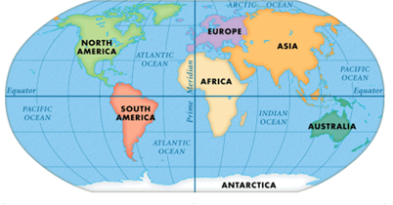  Often world maps are centred on the Meridian Line which runs through London.  (Notice where the UK is on each map.) | 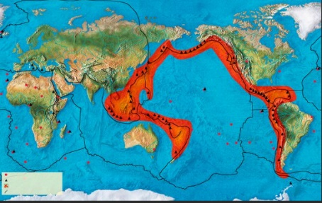  U.K.  This map is centred on the Pacific Ocean. Most of the world’s volcanoes and earthquakes occur in an imaginary ring around the Pacific Ocean. Many tectonic plates meet along this imaginary ring.

Layers of the earth:
The crust, the thin outer layer of the Earth, is made up of huge pieces called tectonic plates. These pieces float on a thick layer of molten rock called the Mantle.  Where they touch each other at their edges various processes can occur which can cause earthquakes, volcanoes and mountains.  Underwater earthquakes can cause a tsunami (huge surges of sea water). | 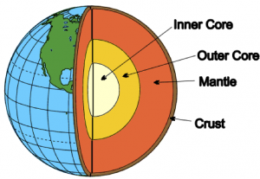

Monday | Tuesday | Wednesday | Thursday | Friday
HWK – Maths Book | HWK – Reading (but reading should be 10/15mins every night)  PE all Y5 classes | HWK – Weekly Skills – Which question will you get right next week? | HWK – Grammar Book | HWK – Spellings

Key Dates:
- Mon 12th Sept - Community Forest day - Science Forces Forest day – date to be confirmed

