In Geography we will be looking at human and physical features of the world arounds us.
Human features are things made by humans.
Physical features are things that grow from the ground or are created by nature.
Listen to the story ‘Mr Gumpy’s Outing’ by scanning this code.

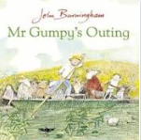

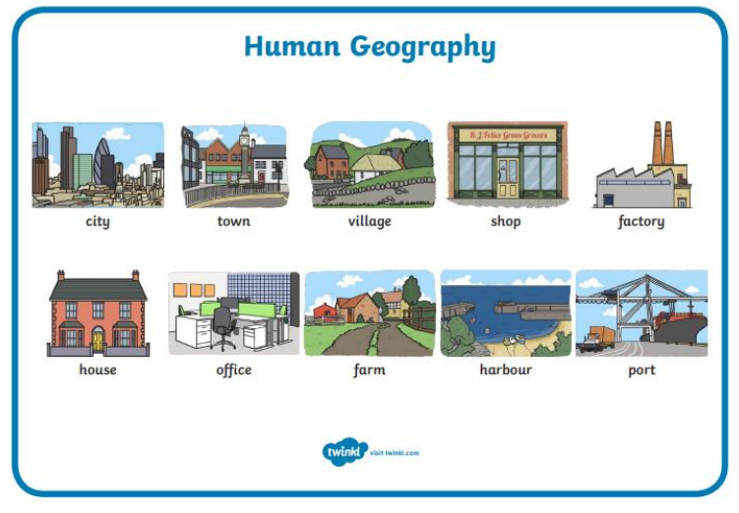
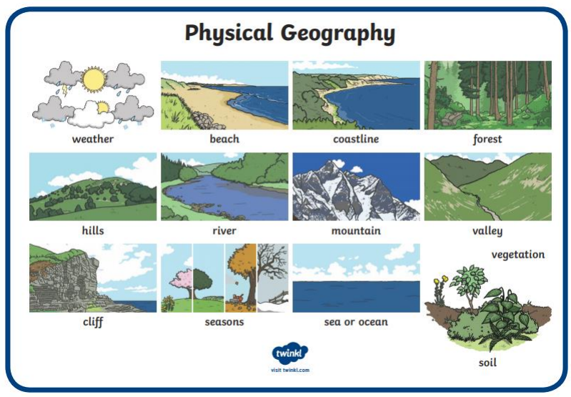

Mr Gumpy takes a trip in his boat, but some children and animals ask to join him and that is when the problems begin!!

Year 1 dates for Spring 2:

Mon 20th February – Zoolab in school
Thurs 23rd February – Local walk
Year 1 PE Days:

Tuesday – Beech
Wednesday – Beech, Birch, Blackthorn
Friday – Birch, Blackthorn
Thurs 2nd March – World Book Day
Thurs 9th March – GLEE Maths workshop
Tues 21st March – Church visit

Year 1 Homework – Reading every night please and practice your rainbow words!!

Monday | Tuesday | Wednesday | Thursday | Friday
- Reading books changed  - New spellings sent home |  |  | - Maths homework sent home | - Phonics Homework  - Spelling test
