World War 2 Family Fact Sheet – Year 6
Describe what happened to Anne Frank – why is it so well-known?  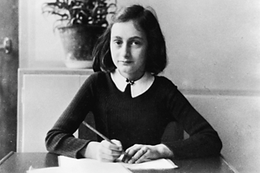 | Anne and her family were Jewish.  During World War Two the Nazis ruled her country. Their laws made the lives of Jewish people very hard.  To escape, Anne and her family went into hiding in an attic.  Two other Jewish families joined them there.  This meant there were eight people hiding in one place.  Anne’s family was discovered and sent to a concentration camp, where she later died.  Anne wrote a diary while she was hiding, it is one of the most famous books ever written.
Describe the story of the Windrush – why did people come from the West Indies?  How were they treated in Great Britain?  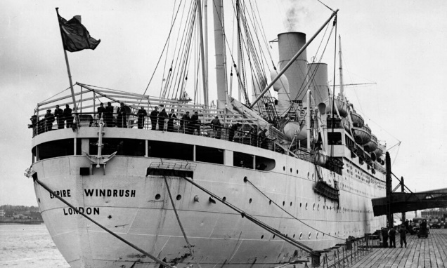 | A large ship called Empire Windrush brought 1,200 immigrants to Britain from Jamaica. This was due to a lower workforce following WW2. The ship arrived in London in 1948. But Empire Windrush wasn’t the only immigrant ship to arrive in Britain – there were many more ships that arrived in Britain over the coming years from various countries. The people that came to Britain on these ships are usually called the “Windrush generation”.  The “Windrush generation” were not all treated kindly, they suffered discrimination and racism.
PE days: Palm Mondays and Thursdays, Pine and Poplar Thursdays and Fridays
Year 6 homework: Reading every night please.
Monday | Tuesday | Wednesday | Thursday | Friday
Maths book |  | Grammar book | Weekly Skills | Spellings
Dates:
Wk beg Mon 9th Jan – Aspiration Week
Wk beg Mon 30th Jan – Homefront Forest Schools (days to be confirmed)
Anderson Shelter detailed diagram:
