YEAR 6 CURRICULUM OVERVIEW

 | Autumn 1  7 weeks |  | Autumn 2  7 weeks 2 days |  | Spring 1  6 weeks | Spring 2  6 weeks | Summer 1  6 weeks | Summer 2  7 weeks
 | Whitby  Room 13  Captain James Cook & the British Empire |  | WW1  Role of Indian Army |  | WW2  Anne Frank  Windrush | Ancient Greeks | Boy 87  Refugees | Adaptation, Evolution & Inheritance  Performance TBC
Events  Charities  May be recognized  Religious celebration – assembly/party/RE teaching  Taught across school  Police visit  Assembly | NSPCC assembly  British Science Festival  Harvest Festival Sept/Oct  Rosh Hashanah  Yom Kippur  Birthday of Guru Nanak  21st Oct Show Racism the Red Card  10th Oct World Mental Health Day |  | 31st Oct Halloween  5th Nov Bonfire Night - Safety  11th/13th Nov Remembrance Day  24th Oct Diwali  19th Dec Hanukah  9th Dec Christmas Jumper Day/Christmas Dinner  24th/25th Dec Christmas  14th-18th Nov Anti-bullying week  18th Nov Children in Need  3rd Dec International Day of persons with Disabilities  Bonfire Safety |  | Chinese New Year  14th Feb Valentine’s Day  4th Feb Children’s Mental Health Week  9th Jan Aspirations Week  27th Jan Holocaust Memorial Day | 21st Feb Shrove Tuesday  22nd Feb Ash Wednesday  2nd March World Book Day  8th March Holi  19th March Mothering Sunday  23rd March Ramadan starts  2nd April Palm Sunday  14th April Vaisakhi  7th April Good Friday  6th – 13th April Passover  9th April Easter Sunday  Comic Relief/Sports Relief  8th March International Women’s Day  Drugs Awareness Talks | 22nd April Earth Day  22nd April Eid ul Fitr  23rd April St George’s Day  May Tour de Yorkshire  Vesak  8th May KS2 SATs testing week  KS1 SATs June  Internet Safety Talks | 10th June Queen’s birthday  18th June Father’s Day  29th June Eid ul Adha  Phonics screening  Sports Week  Transition  Year 6 Performance  Year 6 Fete for Yearbook
Visits and visitors | Community session in forest school  Whitby Residential – Sept 18th  Dracula Experience  Boat Trip  Kam Kaur (RE visitor) |  | Trench building in forest school |  | Home front in forest school  Diane Fairfax – Holocaust talk (26th Jan)  Synagogue visit | Trojan horse building in forest school | Flamingo Land – May  Lister Park – May  LA in forest school SATs build-up | Evolution, Adaptation & Inheritance in forest school  Dahl cooking in forest school  Bikeability
Jigsaw | Being me in my world  Texts: I am Enough, Have you filled a Bucket? Be Kind  1. Help others to feel welcome  2. Try to make our school community a better place  3. Think about everyone’s rights to learn  4. Care about other people’s feelings  5. Work well with others  6. I know how to have a healthy mind - Mental Health Day  7. Choose to follow the Heaton Values - Show Racism the Red card (Friday)  Heaton Values Focus – Commitment  Skills Builder Focus – Staying Positive and Aiming High  SDGs: No Poverty, Quality Education |  | Celebrating difference  Texts: The Night Bus Hero – Bullying  1.Accept that everyone is different  2. Include others when working and playing  3. Anti-bullying week 14th-18th Nov  Know how to help when someone is being bullied  4. Try to solve problems  5. International Day of persons with Disabilities Fri 2nd Dec  5, 6. Try to use kind words x 2 wks  7.Know how to give and receive compliments  Heaton Values Focus – Integrity  Skills Builder Focus – Teamwork and Leadership  SDGs: Reduced Inequalities, Peace, Justice and Strong Institutions |  | Dreams and goals  Texts: Peace and Me by Ali Winter  The Librarian of Basra by Jeanette Winter  1. Stay motivated when doing something challenging  2. Keep trying even when it is difficult Aspirations Week  3. Work well with a partner or group  4. Have a positive attitude Holocaust Memorial Day 27th January  5. Help others to achieve their goals  6. I know how to have a healthy mind Children’s Mental Health Week 4th Feb-11th Feb  Heaton Values Focus – Growth  Skills Builder Focus – Problem Solving and Creativity  SDGs: Affordable Clean Energy, Decent Work and Economic Growth, Industry, Innovation and Infrastructure, Sustainable Cities and Communities | Healthy me  1. Have made a healthy choice  2. Have eaten a healthy, balanced diet  3. Have been physically active International Women’s Day 8th March  4. Have tried to keep themselves and others safe  5. Know how to be a good friend and enjoy healthy relationships  6. Know how to keep calm and deal with difficult situations  Heaton Values Focus – Commitment  Skills Builder Focus – Staying Positive and Aiming High  SDGs: Zero Hunger, Good Health and Well-being, Clean Water and Sanitation | Relationships  1. Know how to make friends  2. Try to solve friendship problems when they occur  3. Help others to feel part of a group  4. Show respect in how they treat others  5. Know how to help themselves and others when they feel upset or hurt  6. Know and show what makes a good relationship  Heaton Values Focus – Integrity  Skills Builder Focus – Teamwork and Leadership  SDGs: Responsible Consumption and Production, Climate Action, Life Below Water, Life on Land, Partnerships for the Goals | Changing me  1.Understand that everyone is unique and special  2. Can express how they feel when change happens  3. Understand and respect the changes that they see in themselves  4. Understand and respect the changes that they see in other people  5. Know who to ask for help if they are worried about change  6, 7. Are looking forward to change x 2 wks  Heaton Values Focus – Growth  Skills Builder Focus – Problem Solving and Creativity  SDGs: Gender Equality
RE | How do Sikhs show commitment? |  |  |  | What do Christians believe about Jesus’ death and resurrection? |  | How does growing up bring responsibilities? | How do Jews remember the Kings and Prophets in worship and life?
Aspiration | Authors  Inventors - Granville Tailor Woods, Thomas Eddison  Programmers - Alan Turing |  | News reporters - Anita Rani  Government ministers  Poets - Amanda Gorman |  | Engineers – Grace Murray-Hopper, computer science military leader  Sam Beaver King - a Jamaican-British campaigner. First came to England as an engineer in the RAF during WW2. King took passage to London on the famous 1948 Empire Windrush  Train drivers  Computer scientists – Alan Turing  Spies – Noor Inayat Khan | Soldiers  Leaders  Politicians - Councilor Imran, Margaret McMillan, Naz Shah | UN ambassador/social activist - Greta Thunberg, Julia Varley (Bradfordian suffragette) | Actors, singers, dancers, performers - Zayn Malik, Dynamo  Directors, sound engineers  Zookeepers  Vets  Al-Jahiz, animal habitat/evolution, Iraq  Linnaeus, Archimedes
Main Text | Room 13 Robert Swindells - WT |  | Where the Poppies Now Grow  Peace Lily  Flo of the Somme  The Christmas Truce |  | Anne Frank  Blitz - WT | Trojan Horse (comic strip version) | Boy 87 - WT | Moth
Supplementary texts | Alma  The Fib, George Layton  Shark Caller – Zillah Bethel  A Pocket of Stars – Aisha Bushby  Octopus – Dianne Wolfer  The Boy who met a Whale – Nizrana Farook  Asha & the Spirit Bird – Jasbinder Bilan |  | How the Grinch Stole Christmas – Dr Seuss (& other texts)  Dr Seuss biography  Trench letters  WW1 newspaper  WW1 newspapers  You Wouldn’t Want to be in the Trenches in World War One! (Alex Woolf) |  | Blitz - WT  The Arrival  Anne Frank  Grandpa’s Great Escape  Adolphus Tips – Morpurgo  Goodnight Mr Tom - E  FArTHER Grahame Baker Smith  NOW OR NEVER: A DUNKIRK STORY  Windrush child | Trojan Horse  Theseus and the Minotaur  Medusa  Archimedes’ Bath  Famous Ancient Greeks | Boy at the Back of the Class  Refugee Poem  When I Get Older  Wisp - A story of Hope – Zana Fraillon  My name is not Refugee – Kate Milner | Zoo  Gorilla  Penguin Poetry  Holes – WT  Running Wild – Michael Morpurgo
Guided Reading texts | Room 13 x 4 weeks  Suspense extracts x 1 week  Non-fiction Whitby info  Whitby poetry |  | Where the Poppies Now Grow  Peace Lilly  The Christmas Truce- Place where peace was found  Flo of the Somme  War Horse - E  WW1 newspaper |  | WW2 newspaper  Blitz x 3 weeks  Goodnight Mr Tom - E  FArTHER  Coming to England by Floella Benjamin | Ancient Greek stories – Pandora’s box, Icarus and Daedalus, Theseus and the Minotaur  Non-fiction Ancient Greece | Boy 87  Refugee Poem  When I Get Older  Boy at the Back of the Class | Moth  Skellig  Animal newspapers  Animal poetry  Zoo  Gorilla  Solo
Guided Reading objectives  Not separated into terms, weekly flow | Solve unknown words by:  Reading around the word  Pronouncing words  Substituting words  (Speed words)  Using synonyms and antonyms to find meaning  Effects of language:  What impression does that give?  Match a passage to a toolkit.  Why is that effective?  Dealing with questions:  Point, evidence, explanation grids.  Scan texts for event-based questions, re-read the event/section, list elements of the event, use the list to answer the question.  Connecting sections of the text:  Compare two parts of a text or two characters stating similarities and differences.  Show understanding by:  Making and justifying inferences based on evidence from the text, general knowledge and wider reading. (What makes you think that?)  Explain how an author makes an object or character stand for a theme or idea (symbolism).  Improve understanding of the text by Reciprocal reading  Connecting sections of the text:  Build a character/setting description or follow a theme through a text, citing examples from across the text.  Summarise and clarify:  Summarise a group of paragraphs into a single phrase.  Summarise non-fiction in graphic organisers.  Box up a passage.
Story plot | Tale of fear | Meeting Tale |  |  | Historical Journey – evacuation | Overcoming an obstacle  Myth / legend  Battle  Additional – dialogue between characters  Suspense scene (ghost over battlefield) | Diary, 3 parts of story as main character
Toolkit focus | Suspense  WAGOLL: Chpt 1 Room 13 adapt  Innovate: Alma  Invent: Spooky Setting in Whitby | Characterisation  Dialogue  Description – Setting  WAGOLL: Sal and Fliss from Room 13  Innovate: Ray and Ben (Where the Poppies Now Grow)  Invent: Character’s meeting in the trenches |  |  | Description – Setting  Characterisation  Dialogue  Flashback  Moving the Story On  WAGOLL: Anne Frank  Innovate: Anne’s Journey to Concentration Camp  Invent: Evacuation of a Child/Soldier Going to Barracks (both start in London) | Description – Setting  Characterisation  Dialogue  Flashback  Moving the Story On  Dramatic Action  WAGOLL: Trojan Horse from POV of King  Innovate: Trojan Horse from another character’s POV  Invent: Different Greek Myth from character’s POV | Description – Setting  Characterisation  Dialogue  Flashback  Moving the Story On  Dramatic Action  WAGOLL: Alma diary  Innovate: Event from the story  Invent: What happens after the story?
Writing techniques | 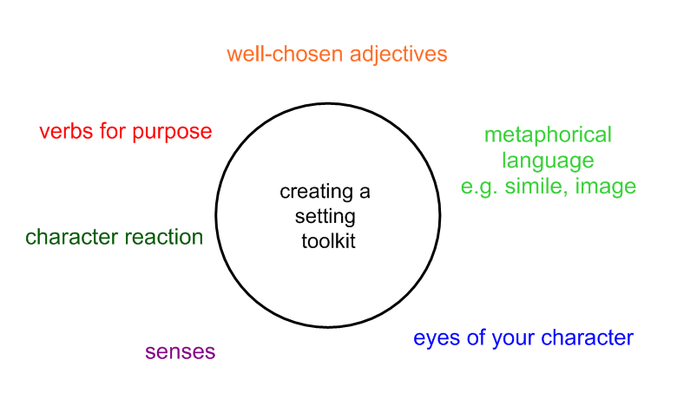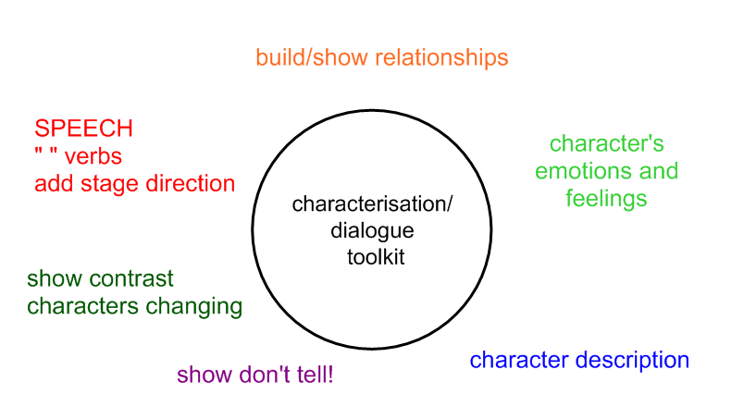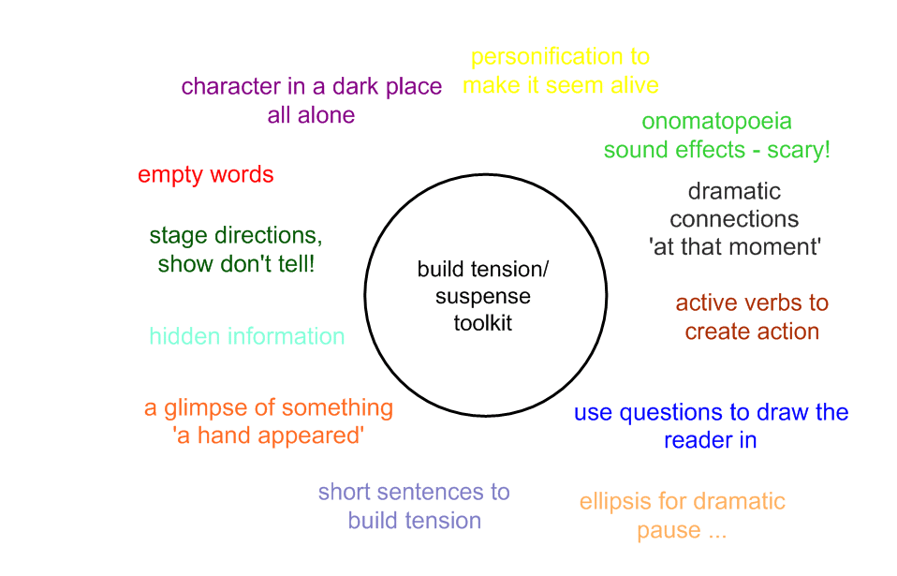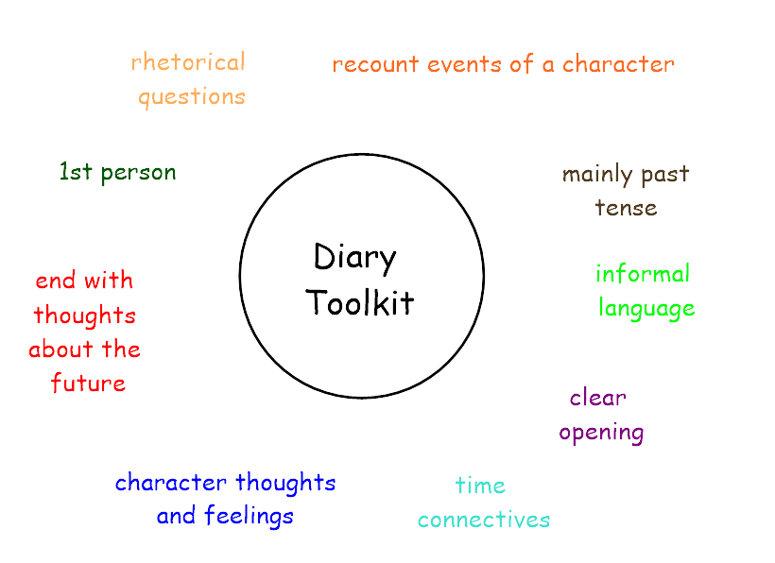
Innovation and invention | Imitate – Teacher written using Chapter 1 Room 13  Innovate – Alma, heavily modelled  Invent – Own tale of fear using Whitby as inspiration, haunted place focus | Imitate – Teacher written meeting tale  Innovate – story two best friends WW1  Invent – own meeting tale inspired by WW1 (soldier and girl, two soldiers opposing sides) |  | Imitate – Teacher written journey narrative Anne Frank  Innovate – Anne’s journey to concentration camp  Invent – Evacuation journey to countryside |  | Imitate – Teacher written Trojan Horse tale written from King Priam’s viewpoint  Innovate – Own character introduction  Invent – Own character rest of tale | Imitate – Alma diary  Innovate – Diary 1 Shif’s escape from compound  Invent – Diary entries 2 & 3, free choice using whole text Boy 87, 1 following story given e.g. first day at school/meeting mother again
SPAG | Speech punctuation  Cohesion within a paragraph  Synonyms and antonyms  Ellipsis | Parenthesis (),-  Colon for a list  Dash as an aside |  | Passive Voice – subject/object  Active voice  ‘A loving kiss was placed upon…’  Hyphens ‘war-torn, ‘power-hungry’  Colons for a list  Colons to separate clauses : ;  Bullet points |  | Colons to separate clauses : ; | All KS2 Review
Non fiction | 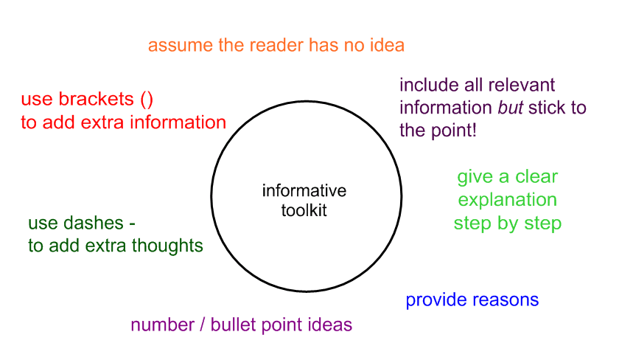  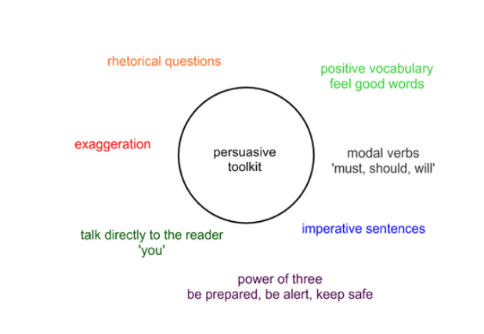  WAGOLL: Flamingo Land  Invent: Persuasive Leaflet - Whitby | 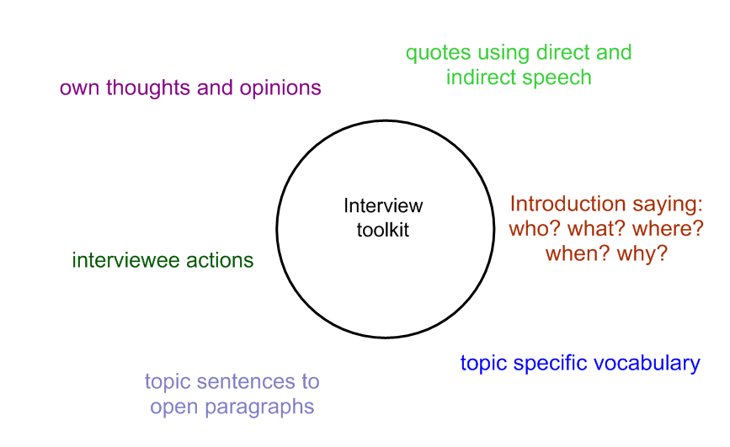  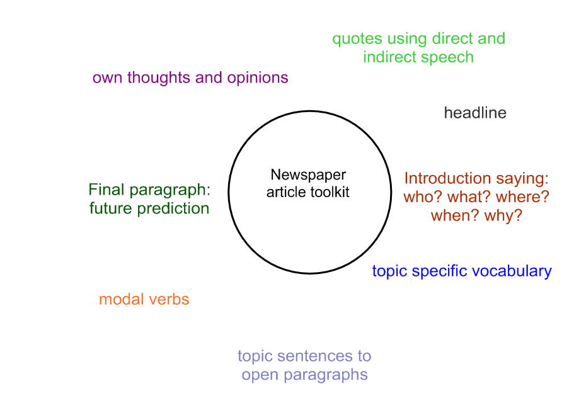  WAGOLL – Dracula death newspaper article  Invent: Newspaper – Shooting Franz Ferdinand |  | 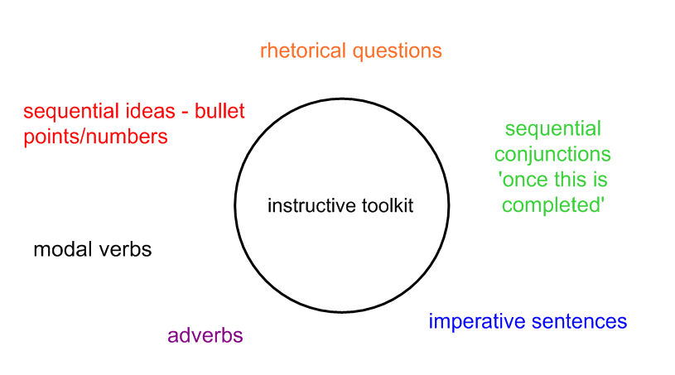  WAGOLL – How to survive the trenches  Invent - How to survive the Blitz |  | WAGOLL – Dracula interview  Invent – Alexander the Great interview | 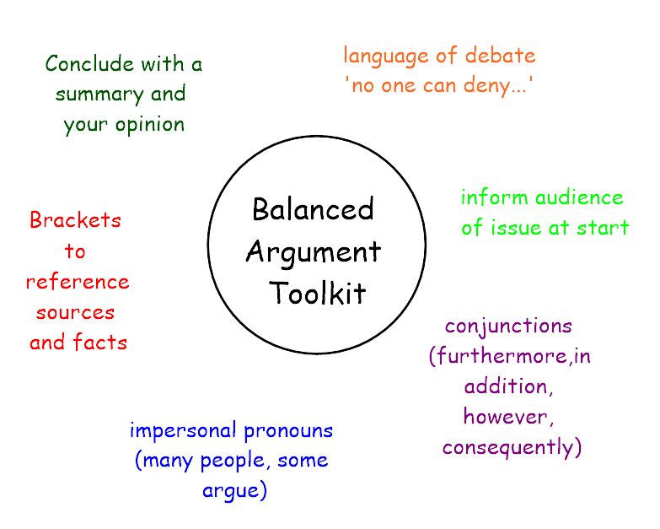  WAGOLL – Should the Amazon tribes use the natural medicines they find in the Rainforest?  Invent - Should Britain take in refugees? |  | 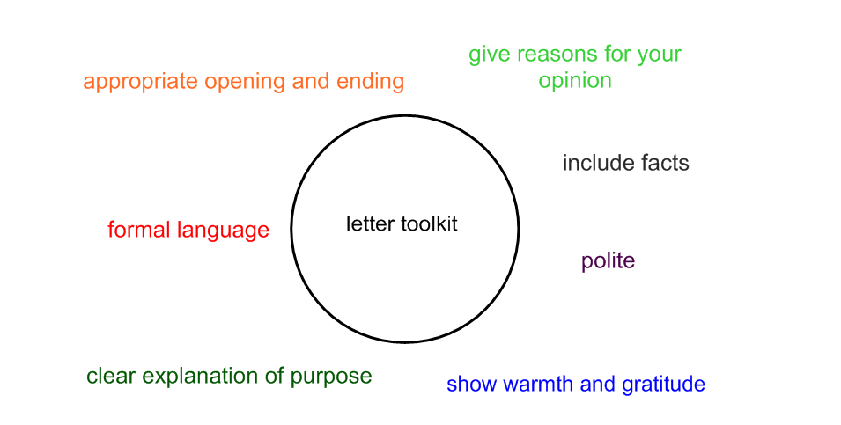  Letter to Thank Flamingo Land  Independent piece – Should animals be kept in Captivity?  Further invent – Should we use Tiger bones in medicine?
Poetry structure | Descriptive narrative poem – Dracula entering Abbey  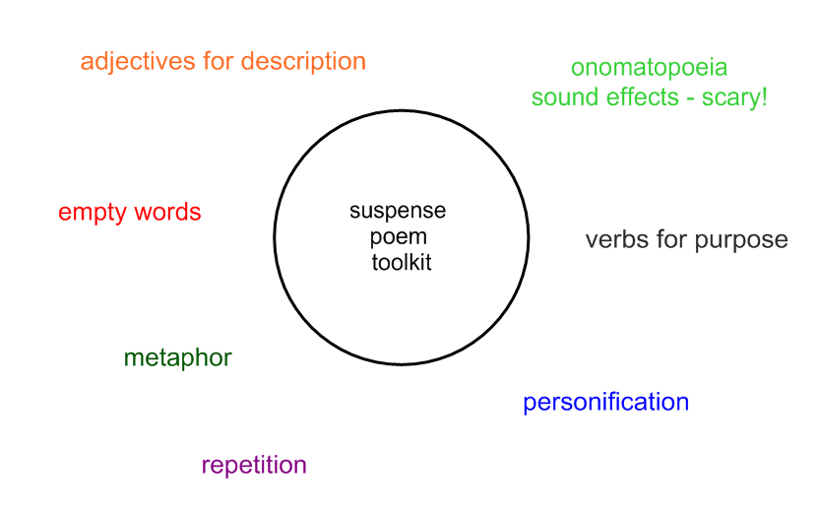 | Noise poem inspired by trenches  Epitaph of a WW1 soldier  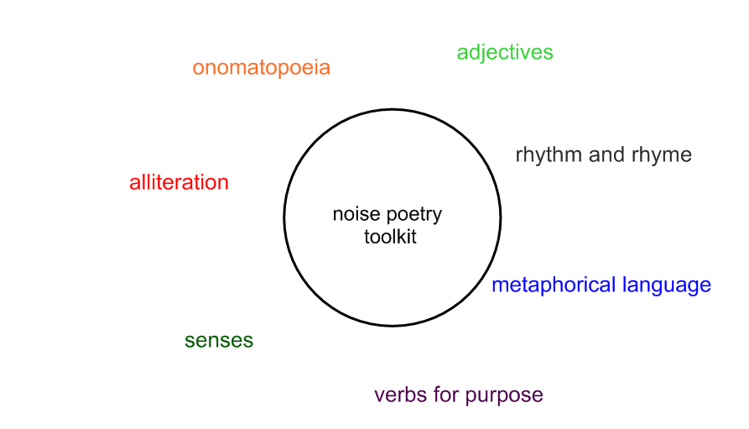  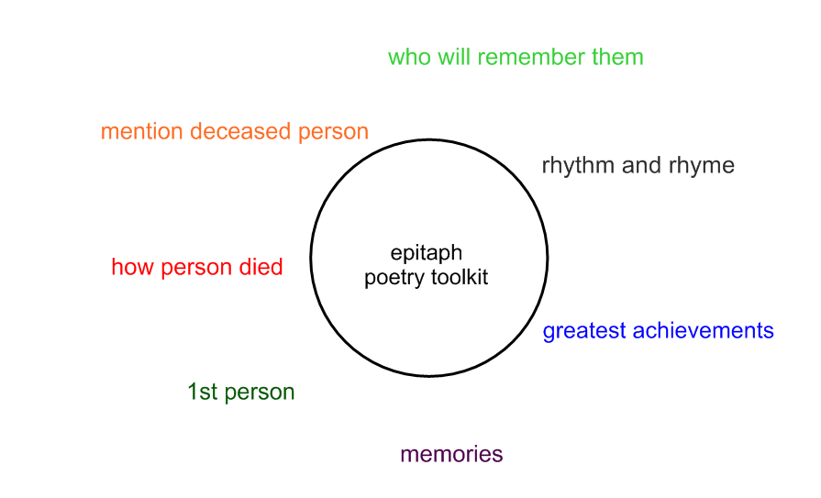 |  | Revisit narrative poem from GR  Description of London during Blitz/countryside WW2. |  | Figurative poetry –  Greek Warship  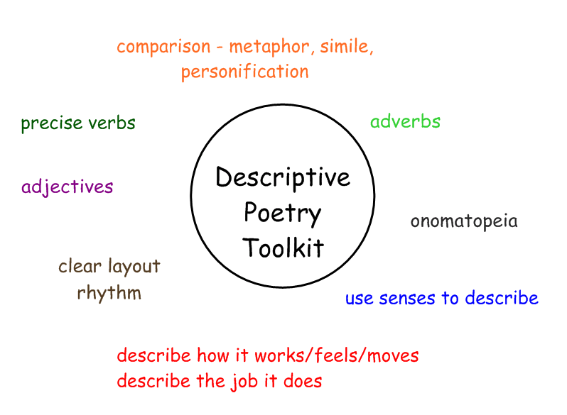 | Feelings poetry –  WAGOLL Sadness  Innovate Anger  Invent Hope  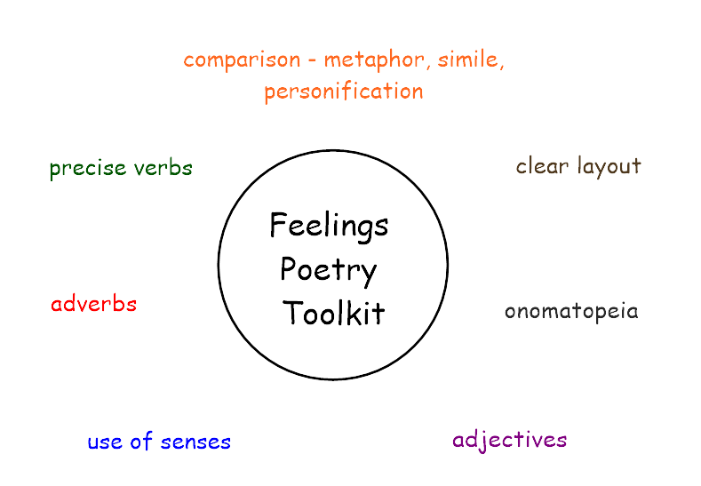 |  | Descriptive poetry – Tigers  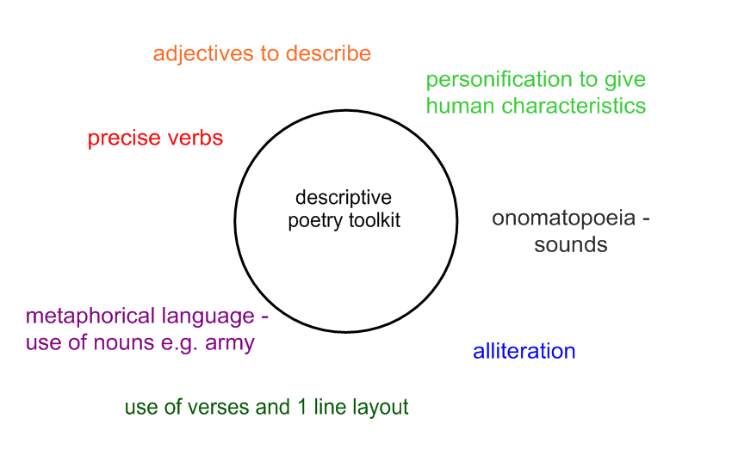
Science coverage | Electricity |  |  | Light |  | Animals including humans  Classification (introduction) |  |  | Evolution & Inheritance  Living things and their habitats  Tigers (Sumatran), orangutans, elephants, Burmese python, penguins (Humboldt, Rockhopper & emperor), Asian jungle, Antarctic
Science working scientifically/  skills | Question, use evidence, measure, test, record, report, present.  Read, spell and pronounce scientific vocab. |  |  | Question, use evidence, measure, test, record, report, present.  Read, spell and pronounce scientific vocab. |  | Question, use evidence, measure, test, record, report, present.  Read, spell and pronounce scientific vocab. | Question, use evidence, measure, test, record, report, present.  Read, spell and pronounce scientific vocab. |  | Question, use evidence, measure, test, record, report, present.  Read, spell and pronounce scientific vocab.
Topic Questions for Assessment | Where is Whitby (describe in detail)?  What writing techniques do you use to persuade? Provide some examples.  Draw a diagram of a circuit with a bulb, switch and battery.  Locate Whitby & Bradford on this map and plot a journey route.  Who was Captain James Cook? What is he remembered for? | What ignited the beginning of WW1? Describe the event.  What was life like for soldiers in the trenches?  What role did the Indian Army play during WW1? How did Great Britain treat those who fought for GB from overseas after the war?  Who were the allied forces and the central powers? |  | How did technology affect WW2? (Comparison with WW1 - focus on engineering development)  What was the Blitz? What did Britain do to survive the Blitz?  Describe what happened to Anne Frank – why is it so well-known?  Describe the story of the Windrush – why did people come from the West Indies? How were they treated in Great Britain? |  | When did the Ancient Greeks exist?  What have we learnt from them?  How do we know about the Ancient Greeks?  What/who did they believe in?  What is democracy and why is it valued? | Locate Eritrea on a map of Africa and explain a route a refugee may take to the UK.  Show the borders on a map of Africa and explain the significance of a landlocked country.  What is a refugee and what may make a refugee flee their country?  Explain the difference between a migrant, an asylum seeker, and a refugee.  Explain what a democratic government is.  List some of the UN Rights of a child and explain why they exist. |  | Describe how penguins are adapted to survive their environment.  Describe Henri Rousseau’s painting ‘Surprised’.  How are tigers classified? What family do they belong to? Describe their natural habitat.  Who is David Attenborough?  What are fossils and what do they provide?
History | History of Whitby Abbey  Dracula  Captain James Cook and the  British Empire | WW1  A theme in British history that extends pupils’ chronological knowledge beyond 1066  Role of Indian Army during WW1.  (Subedar) Khudadad Khan – first Muslim soldier to receive the Victoria Cross |  | WW2  A theme in British history that extends pupils’ chronological knowledge beyond 1066  Bias, sources, questioning  Books - Noor- Un- Nissa Anayat Khan by Sufiya Ahmed  Windrush child – Benjamin Zephaniah  Now or Never – A Dunkirk story by Bali Rai (Indian soldier)  Dictatorship and plight of Jewish faith during WW2, racism  Sam Beaver King - a Jamaican-British campaigner. First came to England as an engineer in the RAF during WW2. King took passage to London on the famous 1948 Empire Windrush.  Following WW2 – 1947 Commonwealth formation, Windrush migration from West Indies, following later with migration from India/Pakistan to Northern England, reasons behind. |  | A study Greek life and achievements and their influence on the Western world. | History of political struggle in Eritrea and Ethiopia.  Migration, asylum seekers, refugees  Different governing regimes – dictatorship, democratic
Debate Question | Is Dracula real?  Did Captain James Cook really ‘discover’ Australia? | Should Britain have joined the war?  Should Great Britain have treated the Indian Army better following the end of the war? |  | Was it right to evacuate children?  Should Great Britain have treated those on the Windrush better? How? |  | Has the democracy starting in the time of the Ancient Greeks been a positive influence on British society today? | Should Great Britain take in refugees? |  | Should animals be in captivity?  Should we use animals for medicine?
Geography | Map work  Plotting a route  Compare localities – land use, population etc.  Human/physical features | Map work  Europe  World map to showcase British Empire |  | Plotting a route  Aircraft journeys  Route of the Windrush |  | Europe/Asia map  Equator/longitude/longitude - weather | Map work  Plotting route Shif took to Europe from Eritrea  Comparison of Eritrea to UK |  | Map of world with habitats labelled.
Numeracy in Topic | Miles/km | Timeline  Timeline questions  Number of deaths, injured  Distance (woodlands)  Size of trenches (woodlands) |  | Percentages  Angles  Distance  Ratio  Conversion  Multiplication |  | Timeline – negative numbers  Timeline questions | %s, numbers of refugees  Distance travelled |  | Area & perimeter of enclosures  Percentages (space in wild, death)  Distance  Speed = distance over time  Height  Conversion
Art and design  (Sketch books) | Sketching, Haunted house:  Shading  In proportion  Using guides  Kate Lycett  Painting - water colour:  Brush stroke, mixing, colour wheels.  Paintings inspired by Whitby  Artist study – John Freeman | Painting - water colour:  Brush stroke, mixing, colour wheels.  Paintings inspired by Christmas Day Truce  Sketching soldiers in proportion  Martin Impey  Contribution of Indian soldiers to WW1  Sketching the Grinch |  | Sketching in proportion – spitfire - Windrush  Pastel blending  Silhouette |  | Book Art – sketching, use of coloured pencil crayon, lettering.  Clay - medallions | Refugee artwork appreciation  Waves/Desert collage  Hokusai  Tiger sketch – jungle scene  Henri Rousseau |  | Sketching - Tigers  Painting (water colour pencils)  Artist study – Rousseau  Digital photography
Design and technology | Electrical Systems: more complex switches and circuits  Lighthouse |  |  | Bolting and constructing Anderson shelter |  | Book Art techniques  Sawing/drilling miniature Trojan horse | Soft Toys sewing inspired by animals
Computing | Control – Scratch & Electronics  Prog. a lighthouse, Parents Evening  Page Layout - Comic Life – Electricity safety | Video editing - imovie - WW1 Truce, Assembly  Truce poetry |  |  |  | Web Research – Google Inside Search - Gods & Olympics  Greek Warship Poetry | Research – Flamingo Land |  | Drawing Paint – Photoshop Mix – Flamingo Land animals, Parents Evening
Computing Re-visit skills | Page layout – pages – Electricity safety |  |  |  |  | Page layout – pages – Healthy lifestyle poster |  |  | Control – Scratch & Electronics  Prog. hidden spy cameras around woodland
PE – PPA Sports Coach | Tag Rugby | Gymnastics |  | Basketball & Netball |  | Football | Cricket & Rounders |  | Athletics & Dance
PE – Class Teacher | Golf | Gymnastics |  | Table Tennis |  | Athletics | Tennis |  | Variety  Bikeability

