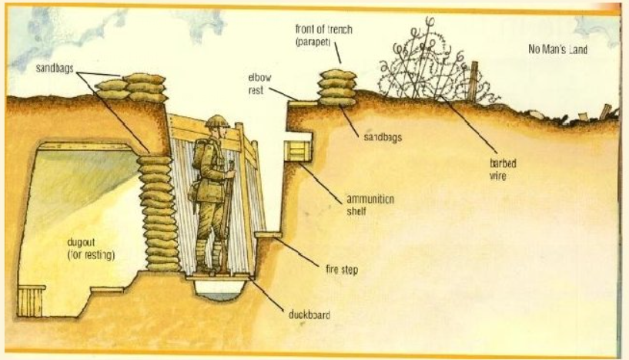
World War 1 Family Fact Sheet – Year 6
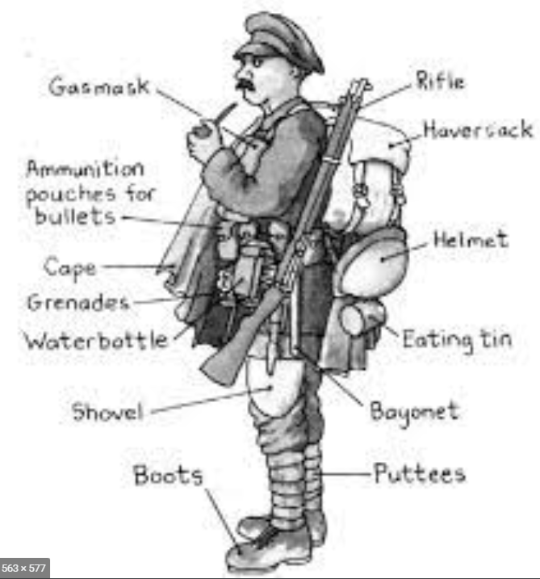

Year 6 dates for Autumn 2:
Tues 1st Nov Fire Safety talks
Mon 7th Nov GLEE reading workshop for Year 6 families
Mon 14th Nov Anti-bullying week
Mon 21st Nov Mock SATs week
Fri 25th Nov Training Day
Mon 28th Nov Trenches in the forest (class day to be confirmed)
Fri 9th Dec Christmas Dinner
Mon 19th Dec Christmas Parties

PE days: Palm Mondays and Thursdays
Pine and Poplar Thursdays and Fridays

Year 6 homework: Reading every night please.
Monday | Tuesday | Wednesday | Thursday | Friday
Maths book |  | Grammar book  (Starting after half term) | Weekly Skills | Spellings

