Year 4 – Autumn 1 – A Tale of Two Mills
Key Words | Definitions
alpaca | A long-haired mammal from South America valued for its wool.
fabric | Cloth or material produced by weaving.
Industrial revolution | A period in history from 1760 to 1840 when goods made by hand changed to being made by machines.
key | A guide that explains what the symbols on a map mean.
loom | A machine used for making fabric.
map | A representation of an area of land or sea showing physical features.
mill | A building with machinery used to make something e.g. fabric.
river | A large, natural stream of water flowing in a channel to the sea.
steam train | A train that is powered by a steam engine.
Victorian | Something which relates to the reign of Queen Victoria.
village | A group of houses and buildings. Smaller than a town.
Where is Saltaire and what is it famous for?
The village of Saltaire is located just outside the city of Bradford in West Yorkshire. It is an example of a Victorian industrial village which includes a textile mill, public buildings and houses for the mill workers. The buildings are great examples of Victorian architecture.

Maps
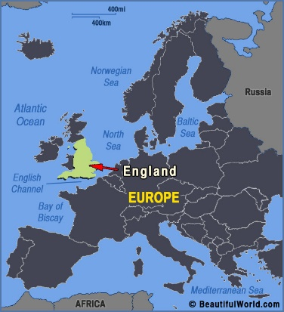 | 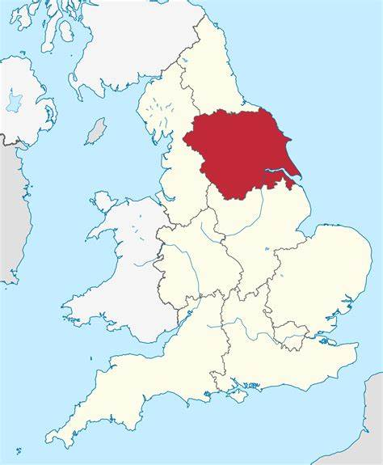  Yorkshire | 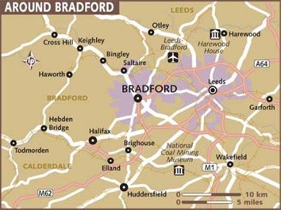  Saltaire

Important figures
Mill Owners
Sir Titus Salt | Samuel Lister | Queen Victoria
1803-1876  Sir Titus Salt built Salts Mill in Saltaire, Bradford, in 1853. He built a village around the mill for his workers in order to help improve their working and living conditions.  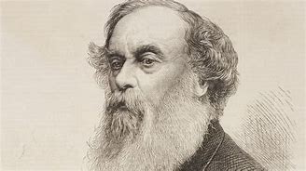 | 1815-1906  Samuel Lister was an inventor and mill owner. He built Lister Mill in Manningham, Braford, in 1873 which at that time was the largest silk factory in the world.  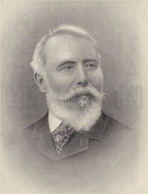 | 1819-1901  Victoria was the Queen of the United Kingdom from 1837-1901. Her reign, which lasted for 63 years, is known as the Victorian era.  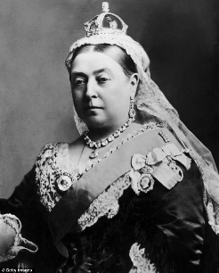

Monday | Tuesday | Wednesday | Thursday | Friday
HWK – Spelling / TTRS  Reading -15 mins | HWK – Spelling Shed/ TTRS  Reading – 15 mins | HWK – Spelling /TTRS  Reading – 15 mins | HWK – Grammar & Maths Book  PE - All | HWK – Spelling Shed / TTRS  Reading 15 mins
Key Dates:
- Week 1 – Community Forest days
- Week 1 - Wednesday 6th September – Saltaire Trip - Week 6 – Lister Park History Walk

