People Who Bring About Change Family Fact Sheet – Year 4
Key Vocabulary |  | Key Dates  Mon 31st Oct – Year 4 Reading Workshop  Thurs 3rd Nov – Larch Library visit  Thurs 10th Nov – Lime Library visit  Thurs 17th Nov – Laurel Library visit  Mon 5th Dec – Larch Lantern Walk  Wed 7th Dec – Lime Lantern Walk  Thurs 8th Dec – Laurel Lantern Walk  w/c 14th Nov – Anti-bullying week  Fri 25th Nov – training day (school closed)  Fri 9th Dec – Christmas dinner  19th Dec – Christmas party  Homework  (with Spelling Shed and TTRS 10min daily)  Monday Spelling Reading  Tuesday Timetables Reading  Wednesday Spelling practise Reading  Thursday Homework Books (Maths and GPS) Reading  Friday Reading
protest | An action expressing the disapproval or objection to something.
picket | A form of protest in which people gather outside a place where a protest is happening.
strike | To refuse to continue working because of working conditions, pay levels, or job losses.
boycott | To stop using a service on purpose as a protest.
leader | A person who leads or commands a group.
discrimination | To treat someone unfairly, particularly because of their race, gender or age.
equality | The state of being equal, especially in status, rights and opportunities.
Key Facts
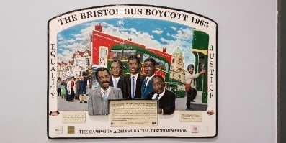  The Bristol Bus Boycott | What was the Bristol Bus Boycott?  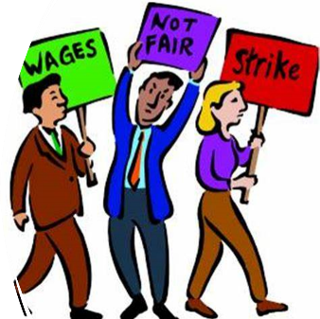  The Bristol Bus Boycott in 1963 was a protest which started because a man named Guy Bailey was refused a job at a bus company because he was black.  What changed because of the Bristol Bus Boycott?  The boycott brought about the Race Relations Act, making racial discrimination illegal in employment.
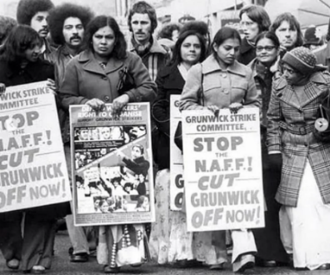  The Sari Strikers | 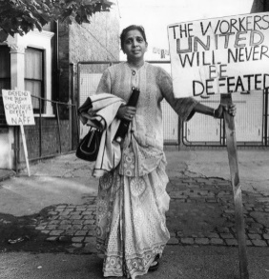  Who were the Sari Strikers and what did they do?  The Sari Strikers were a group of South Asian women, from London, who went on strike to improve the working conditions and seek equal rights in the factories they worked in.  It was led by a woman called Jayaben Desai who stood up for what she believed in – better pay and working conditions. She became an inspiration to other women in Britain.

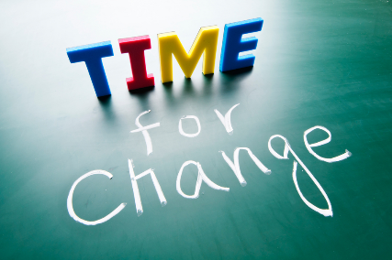

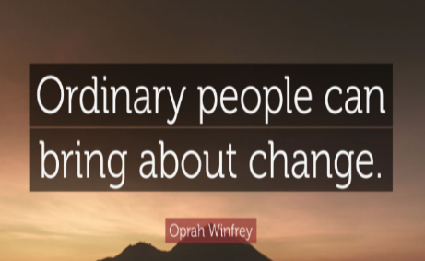
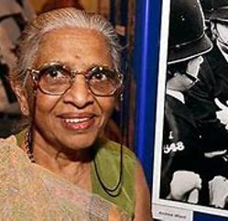
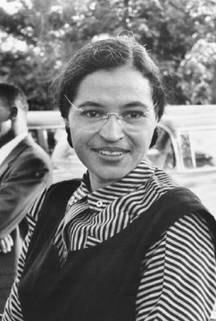
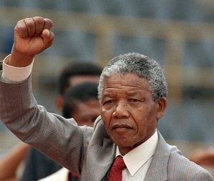
Inspirational people who stood up for what they believed in.
They believed in equality for all.
Jayaben Desai
Rosa Parks
Nelson Mandela

