Castles
Castles are strong buildings, made of stone that were often the home of royalty in medieval times. They were built a long time ago and protected people from attacks.
Learn the features of a castle from the picture below.
Find out about Skipton Castle by scanning this code.

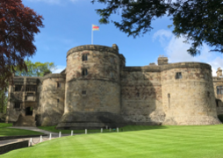
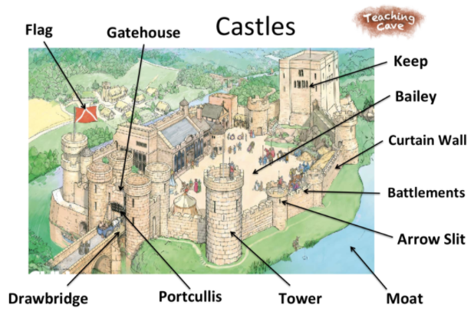

Year 1 important dates:
Skipton Castle is over 900 years old! This medieval castle located in Skipton, England has a banqueting hall, kitchen, bed chamber and privy. You can climb from the depths of the dungeon to the top story of the watch tower!
Tuesday 18th April – Castle building day (in school)
Thursday 18th May – Skipton Castle Trip

Year 1 Homework – Reading every night please and practice your rainbow words!!
Monday | Tuesday | Wednesday | Thursday | Friday
- Phonics reading books changed  - New spellings sent home | - Beech Class PE | - All classes PE | - Maths homework sent home | - Phonics Homework  - Spelling test  - Shared reading book sent home  - Birch and Blackthorn PE
