The Great Fire of London Family Fact Sheet – Year 2
Key Places and Vocabulary |  | Materials that  burn don’t burn  Straw  Stone  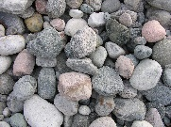
bakery | A place where bread or cakes are made and sold.
River Thames | Many people got a boat on the river Thames to escape the fire.
diary | A personal record of life's events eyewitness. A person who has seen something can give a description of it.
London | The capital city of England.
embers | Small pieces of glowing coal or wood in a dying fire.
fire-hooks | Giant hooks used to pull down houses.
fire-break | A gap made between buildings so fire cannot spread.
flammable | Something that burns easily.
St Paul's Cathedral | A Christian building burnt to the ground in the fire and rebuilt using designs by Sir Christopher Wren.
Key Questions and Facts
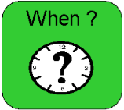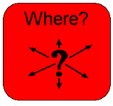 | The fire of London started in a bakery in Pudding Lane on 2nd September 1666.
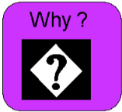 | It hadn't rained for months so the city was very dry.  Lots of people had houses made from wood which burns easily.  Houses were built too close together.  There was no organised fire brigade.
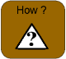did they fight the fire? | They used leather buckets and squirters filled with water to pour on the fire.  They used fire-hooks and gunpowder to make fire-breaks.
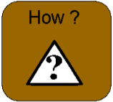did the fire stop? | The fire burned for 4 days. The wind died down and changed direction.  The fire became under control and was finally put out.
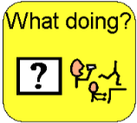after the fire? | 13,200 houses were destroyed by the fire and 70,000 people were left homeless.  Many people left London to live elsewhere, and some slept in tents. London was rebuilt using stone and metal.

Wed 2nd Nov – Y2 Parent workshop  Key dates in Y2:  Tues 8th Nov –Year 2 Woodland Day  w/c 14th Nov – Anti-bullying week  Fri 25th Nov – training day (school closed)  Tues 15th Dec – Christmas Performances (2pm and 6pm)  19th Dec – Christmas party |  | Homework (with SpellingShed and Numbots 10min daily):
 |  | Monday | Tuesday | Wednesday | Thursday | Friday
 |  | Weekly spelling words  Reading | Reading | Spelling practise  Reading | Reading | Maths homework  Reading

