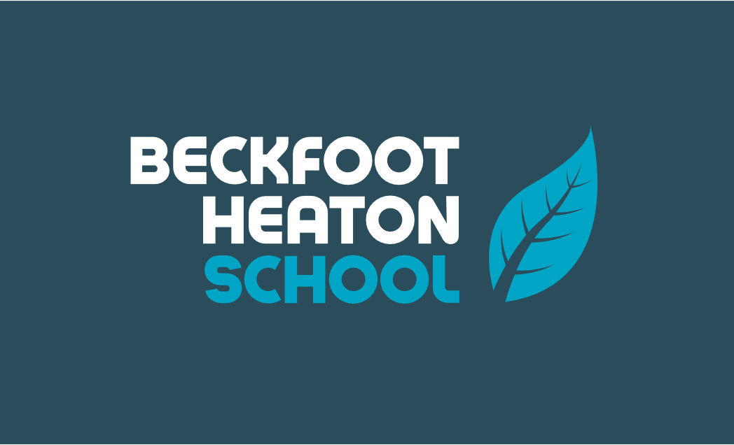
Year 6 – Autumn 1 – Room 13
Key Words | Definitions
abbey | The building or buildings occupied by a community of monks or nuns.
beach | A strip of land covered with sand, pebbles, or small stones at the edge of a body of water, especially by the sea.
city | A human settlement of notable size.
coastline | The land along a coast.
continent | A continuous expanse of land, there are 7 in total.
country | A nation with its own government occupying a particular territory.
county | A division of some countries into smaller areas.
key | A guide that explains what the symbols on a map mean.
map | A representation of an area of land or sea showing physical features.
sea | The expanse of salt water that covers most of the earth's surface and surrounds its landmasses.
symbol | Images to represent real world features on a map.
Where is Whitby and what is it famous for?
Whitby is on the East Coast, in North Yorkshire. It is a seaside town famous for its abbey, it has a fishing port and Captain Cook learned seamanship here. Whitby jet was mined here by the Romans and Victorians, Whitby is associated with the novel and character Dracula.

Maps
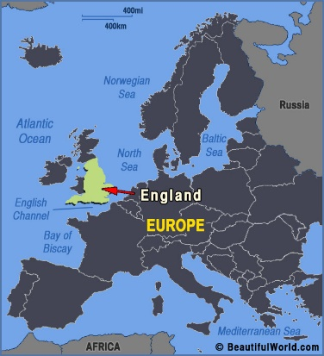 | 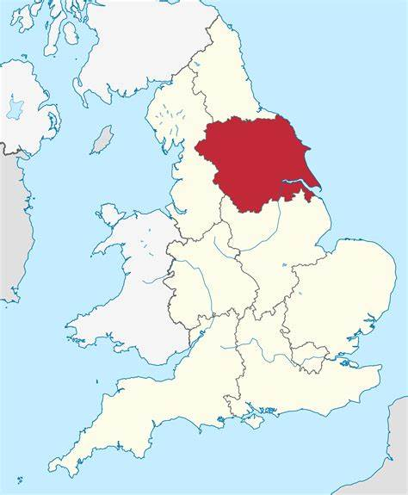  Yorkshire | 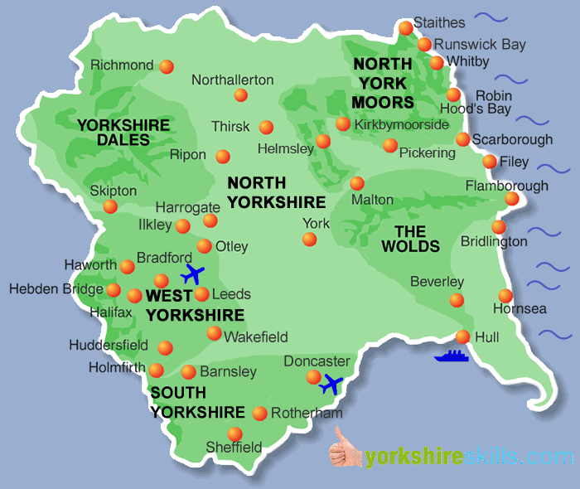  Whitby

Important figures
Explorers
Captain James Cook | Marie Tharp | Dracula | Vlad the Impaler
Captain James Cook was a British explorer, navigator, cartographer, and captain in the British Royal Navy, famous for his three voyages between 1768 and 1779 in the Pacific Ocean and to Australia. 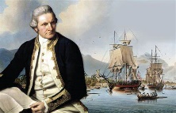 | Marie Tharp was an American geologist and oceanographic cartographer. In the 1950’s she helped to produce the first scientific map of the Atlantic Ocean floor. | 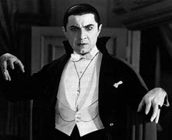  Dracula is a fictional vampire, created by Bram Stoker, who lives in Whitby. He is believed to live in the ruins of the Abbey. | Vlad the Impaler lived in Transylvania in the 15th Century. He was known for his cruel methods of punishing his enemies and is believed to be who Bram Stoker based his character Dracula on.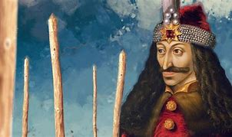

Monday | Tuesday | Wednesday | Thursday | Friday
HWK – Maths Book  PE - All | HWK – Reading | HWK – Weekly Skills  PE - All | HWK – Grammar Book | HWK – Spellings
Key Dates:
- Week 1 – Community Forest days
- Tuesday 19th September – Whitby Trip

