Y3 Family Fact Sheet: - Rivers and Settlements
With a focus on Egypt and the Ancient Indus Valley.
- Where in the world is Egypt? What is the climate like?
- Why was and is the River Nile so important to Egyptians?
- Where in the world is Pakistan and India? What is the climate like?
- Why was the River Indus so important to the ancient Indus civilisation?

Key words you need to learn the meaning of and their spelling.
civilisation | A structured, organised, and advanced group of similar people.
settlement | A place where people live.
trade | Buying / selling / swapping things you have with other people.
population | The number of people in a place.
human geographical features | These are things on planet Earth that humans are responsible for e.g., built cities, changing the plants grown, the ways communities are organised.
irrigation | Humans controlling water so food crops grow

Key words you need to learn the meaning of and their spelling.
physical geographical features | These are naturally occurring things on planet Earth e.g.,’ mountains, rivers, forests, weather.
river source | Where a river starts as a tiny stream.
river mouth | Where a river runs into the sea.
river course | The route a river takes
river flood | When a river is full, and the water goes over the banks into other areas of normally dry land
river sediment | Tiny particles (dirt) carried in river water.
river delta | Land made from sediment at the mouth of a river.
equator | The imaginary line around the middle of the earth.
climate | The most common weather in a place.

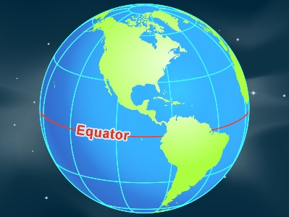  The equator is an imaginary line around the centre of the Earth. | 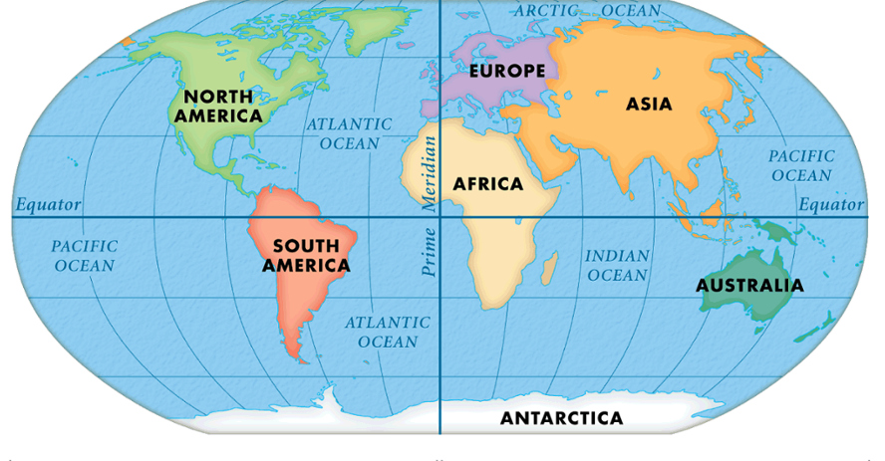  If you imagine peeling off the surface of the Earth and laying it flat, this is what it would look like.  The equator is the horizontal blue line. (The vertical line is prime meridian; it runs through London and is used to calculate time and position all around the world.)
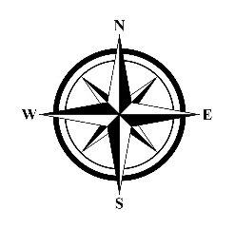
United Kingdom (Britain )
India
Pakistan
Egypt
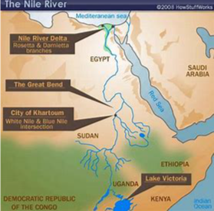
River Nile and Egypt:
- The River Nile runs through Egypt and other countries.
- Egypt is in the north-east of the African continent.
- Without the River Nile, Egypt would be all desert because it is a dry climate. Only 3cm of rain falls across the country. (Average rainfall for Bradford is 106cm each year).
- Each year the River Nile floods which provides water and sediment for plants to grow.
- Because of these floods people have made settlements near the river so they have water to drink and plants to eat.
- There have been large settlements along the River Nile for 5000 years. The early people in these settlements are known as the Ancient Egyptians.

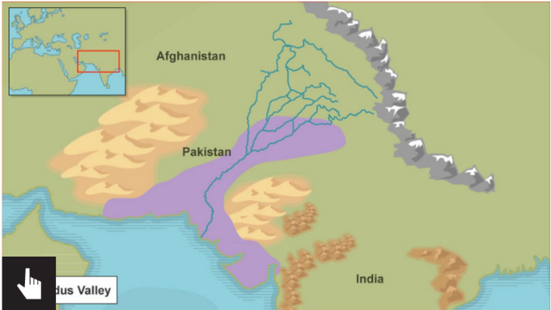
Indus River and Ancient Indus Civilisation:
- The Indus River flows through Pakistan and other countries.
Himilayan Mountains
- Pakistan is on the continent of Asia.
- The climate of this region is mixed because it is mountainous and because there are monsoons (very wet periods every year).
- There have been large, settlements along the Indus River for 5000 years. The early people and settlements are known as the Ancient Indus Civilisation.
- These settlements were in the purple area on the map (modern day Pakistan and India) ...

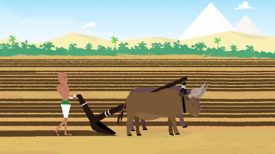  Farmer in Ancient Egypt. |  | Living near a river is good because:  - Transport links so you can trade  - Water for drinking and farming  - Water for energy

