Dragonory Family Fact Sheet – Year 4
Key Vocabulary |  | Key Dates  Wk beginning Mon 9th Jan – Aspiration Week  12th January – Lime Library Visit  19th January – Linking School Video Call  26th January – Sikh Workshop (in school)  Homework  (with Spelling Shed and TTRS 10min daily)  Monday Spelling Reading  Tuesday Timetables Reading  Wednesday Spelling practise Reading  Thursday Homework Books (Maths and GPS) Reading  Friday Reading  PE Day: Tuesday (trainers can be brought in a bag if required)  Swimming Day: Friday
Sikhism | Sikhism is a major world religion. Sikhs believe one God and the equality of all men and women.
Guru Nanak | Guru Nanak was the founder of Sikhism.
Kesh | Kesh means hair. Sikhs make a promise not to cut their hair but to let it grow as a symbol of their faith.
Kangha | The Kangha is a small wooden comb. Sikhs use this to keep their hair in place and as a symbol of cleanliness.
Kara | The Kara is a steel bangle worn on the arms of Sikhs.
Kachera | The Kachera are short trousers worn as underwear.
Kirpan | The Kirpan is a warrior's sword. These days a tiny one if worn by Sikhs as a symbol of dignity and respect.
Key Facts
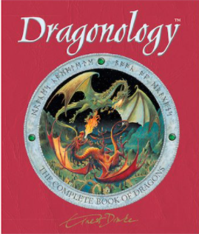  Our writing this half term will focus on dragons. | 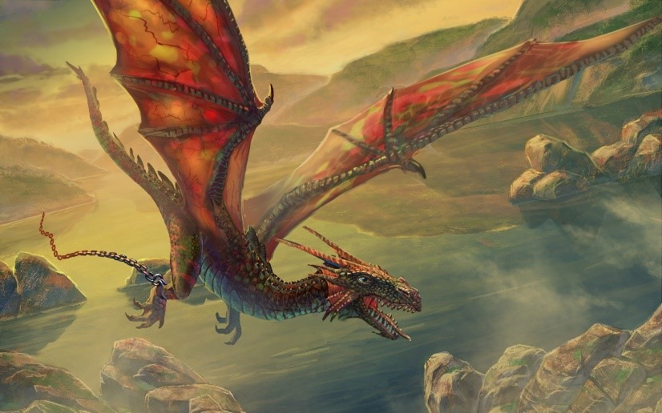  What are dragons?  Dragons are mythical creatures that have appeared in most ancient cultures and traditions. They could be good or evil and live almost anywhere. In western cultures, dragons have been depicted as having wings, horns and being able to breathe fire. In eastern cultures, they are shown as wingless, four-legged creatures that are very intelligent.
Science – States of Matter and The Water Cycle.  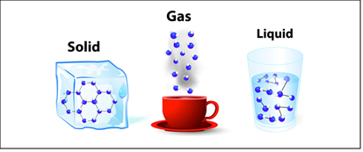 | All matter (stuff) is made from particles. They are tiny and you can only see them with a microscope.  In a solid, the particles are packed tightly together and cannot move easily. All solids have a certain shape and they do not take the shape of a container.  In a liquid, the particles can flow over one another. Liquids take the shape of the container, and they can be poured.  In a gas, particles are not linked tightly and can spread out and fill up a container. They can’t be seen but can be smelt or heard.

