**Stage 2**

**PROMPT sheet**

**2/1 Know the 2, 3, 5, 10 times tables**

|  |  |  |  |  |
| --- | --- | --- | --- | --- |
| 0 | x | 2 | = | 0 |
| 1 | x | 2 | = | 2 |
| 2 | x | 2 | = | 4 |
| 3 | x | 2 | = | 6 |
| 4 | x | 2 | = | 8 |
| 5 | x | 2 | = | 10 |
| 6 | x | 2 | = | 12 |
| 7 | x | 2 | = | 14 |
| 8 | x | 2 | = | 16 |
| 9 | x | 2 | = | 18 |
| 10 | x | 2 | = | 20 |
| 11 | x | 2 | = | 22 |
| 12 | x | 2 | = | 24 |

|  |  |  |  |  |
| --- | --- | --- | --- | --- |
| 0 | x | 5 | = | 0 |
| 1 | x | 5 | = | 5 |
| 2 | x | 5 | = | 10 |
| 3 | x | 5 | = | 15 |
| 4 | x | 5 | = | 20 |
| 5 | x | 5 | = | 25 |
| 6 | x | 5 | = | 30 |
| 7 | x | 5 | = | 35 |
| 8 | x | 5 | = | 40 |
| 9 | x | 5 | = | 45 |
| 10 | x | 5 | = | 50 |
| 11 | x | 5 | = | 55 |
| 12 | x | 5 | = | 60 |

|  |  |  |  |  |
| --- | --- | --- | --- | --- |
| 0 | x | 10 | = | 0 |
| 1 | x | 10 | = | 10 |
| 2 | x | 10 | = | 20 |
| 3 | x | 10 | = | 30 |
| 4 | x | 10 | = | 40 |
| 5 | x | 10 | = | 50 |
| 6 | x | 10 | = | 60 |
| 7 | x | 10 | = | 70 |
| 8 | x | 10 | = | 80 |
| 9 | x | 10 | = | 90 |
| 10 | x | 10 | = | 100 |
| 11 | x | 10 | = | 110 |
| 12 | x | 10 | = | 120 |

|  |  |  |  |  |
| --- | --- | --- | --- | --- |
| 0 | x | 3 | = | 0 |
| 1 | x | 3 | = | 3 |
| 2 | x | 3 | = | 6 |
| 3 | x | 3 | = | 9 |
| 4 | x | 3 | = | 12 |
| 5 | x | 3 | = | 15 |
| 6 | x | 3 | = | 18 |
| 7 | x | 3 | = | 21 |
| 8 | x | 3 | = | 24 |
| 9 | x | 3 | = | 27 |
| 10 | x | 3 | = | 30 |
| 11 | x | 3 | = | 33 |
| 12 | x | 3 | = | 36 |

**Count in 10s**

|  |  |
| --- | --- |
| tens | units |
| **3** | **7** |

Counting up in tens this digit changes:

**3**7 **4**7 **5**7 **6**7 **7**7 **8**7

|  |  |
| --- | --- |
| tens | units |
| **2** | **8** |

**2/2 Place value**

**28 means 2 tens and 8 units (ones)**

**20 and 8**

**2/3 Estimate numbers**

* **Eyeball estimate**



Here are 3 sweets



**Use this to estimate larger amounts**







* **Estimate on a number line**

**Fill in the half way number first**

**Then split up the half with the arrow**

7

**0 10**

**5 6 7 8 9**

12

**10 20**

**11 12 13 14 15**

**2/4 Order numbers**

|  |  |
| --- | --- |
| **Ten** | **Unit** |
| 3 | 7 |
| 3 | 2 |
| 7 | 6 |
| 6 | 2 |

* Begin at the tens and compare

76 is the biggest

62 is next biggest

|  |  |
| --- | --- |
| **Ten** | **Unit** |
| 3 | 7 |
| 3 | 2 |
| 7 | 6 |
| 6 | 2 |

* Move to the units and compare

**Order is: 76 62 37 32**

**2/4 (continued) Inequality symbols**

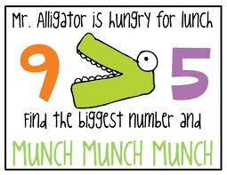

**We say: 9 is bigger than 5**

**We write: 9 > 5**

**We say 5 is smaller than 9**

**We write: 5 < 9**

**2/5 Numbers in figures and words**

1 one

2 two

3 three

4 four

5 five

6 six

7 seven

8 eight

9 nine

10 ten

11 eleven

12 twelve

13 thirteen

14 fourteen

15 fifteen

16 sixteen

17 seventeen

18 eighteen

19 nineteen

20 twenty

21 twenty one

22 twenty two

23 twenty three

24 twenty four

25 twenty five

26 twenty six

27 twenty seven

28 twenty eight

29 twenty nine

30 thirty

40 forty

50 fifty

60 sixty

70 seventy

80 eighty

90 ninety

100 one hundred

**2/6 Addition & subtraction problems**

**Words for ADD**

plus

total

sum of

altogether

**Words for SUBTRACT**

difference

take away

how many left?

how many less?

how many more?

**2/7 Addition facts to 10**

|  |  |  |  |  |  |  |  |  |  |
| --- | --- | --- | --- | --- | --- | --- | --- | --- | --- |
|  |  |  |  |  |  |  |  |  | **10** |
| **1** |  |  |  |  |  |  |  |  | **9** |
|  | 2 |  |  |  |  |  |  |  | 8 |
|  |  | 3 |  |  |  |  |  |  | 7 |
|  |  |  | 4 |  |  |  |  |  | 6 |
|  |  |  |  | 5 |  |  |  |  | 5 |
|  |  |  |  |  | 6 |  |  |  | 4 |
|  |  |  |  |  |  | 7 |  |  | 3 |
|  |  |  |  |  |  |  | 8 |  | 2 |
|  |  |  |  |  |  |  |  | 9 | 1 |

|  |  |  |  |  |
| --- | --- | --- | --- | --- |
| 0 + 10 | 1 + 9 | 2 + 8 | 3 + 7 | 4 + 6 |
| 10 + 0 | 9 + 1 | 8 + 2 | 7 + 3 | 6 + 4 |
|  |  | 5 + 5 |  |  |

**Addition facts to 20**

|  |  |  |  |  |
| --- | --- | --- | --- | --- |
| 10 + 10 | 11 + 9 | 12 + 8 | 13 + 7 | 14 + 6 |
| 15 + 5 | 16 + 4 | 17 + 3 | 18 + 2 | 19 + 1 |
|  |  | 20 + 0 |  |  |

**Subtraction is the inverse of addition**

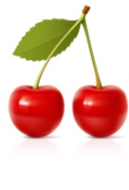[](http://www.portwallpaper.com/image/30508-red-cherry.html)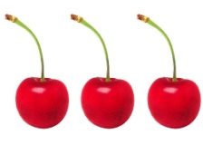

=

+

3 + 2 = 5

[](http://www.portwallpaper.com/image/30508-red-cherry.html)

-

5 - 2 = 3

[](http://www.portwallpaper.com/image/30508-red-cherry.html)

-

5 - 3 = 2

**2/8 Add & subtract**

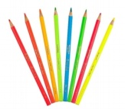

**= 28**

**20 + 8 = 28**

**20**

**8 +**

**28**





**28 - 3 = 25**

**28**

**3 -**

**25**





**28 - 10 = 18**

**28**

**10 -**

**18**





**28 - 13 = 15**

**28**

**13 -**

**15**

**2/9 Add & subtact**



**7 + 3 = 10 is the same as 3 + 7**

**10 – 7 = 3 is NOT the same as 7-10**

**2/10 Add & subtact**

Fact family for add and subtract

1. + 7 = 20

20 - 13 = 7 20 - 7 = 13

**2/11 2, 5, 10 times tables**

* **See 2/1**

**Odds & even numbers**

* **Even numbers** – can be paired up



**Tip – the last digit always 0 2 4 6 8**

* **Odd numbers –** cannot be paired up



**Tip – the last digit always 1 3 5 7 9**

**2/12 Multiply & divide**

**Words for MULTIPLY**

triple

double

product

times

**Words for DIVIDE**

split

share

**Words for EQUALS**

gives

is

Fact family for multiply and divide

7 x 5 = 35

35 ÷ 5 = 7 35 ÷ 7 = 5

**2/13 Multiply & divide**



**7 x 5 = 35 is the same as 5 x 7**



**35 ÷ 7 = 5 is NOT the same as 7÷35**

**2/14 Multiply & divide**

**Example1**: Here are 20 sweets to share

Each child gets 5 sweets

How many children are there?

Divide them up into groups of 5 sweets-like this







There must be 4 children

**Example2**: Here are 12 marbles to share

There are 4 children.

How many marbles does each get?

Divide them up into 4 groups - like this

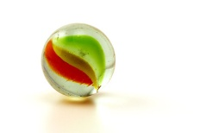

Each child gets 3 marbles

**Repeated addition (Multiplication)**

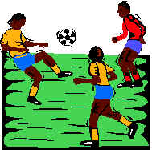

Here are 3 footballers.

How many legs do they have altogether?

Addition sentence Multiplication sentence

2 + 2 + 2 = 6 3 x 2 = 6

Repeated addition is the same as multiplication

|  |  |
| --- | --- |
| **Addition sentence** | **Multiplication sentence** |
| 5 + 5 + 5 + 5 = 20 | **4 x 5 = 20** |
| 10 + 10 + 10 = 30 | **3 x 10 = 30** |

**Repeated subtraction (Division)**

Repeated subtraction is the same as division

**15**

This is the same as 15 ÷ 5 = 3

Because 5 has been subtracted 3 times to get to 0

**-5 (1)**

**10**

**-5 (2)**

**5**

**-5 (3)**

**0**

**2/15 & 16 Fractions**

**To work out a half**

Split into two equal parts

**YES NO!!!!**



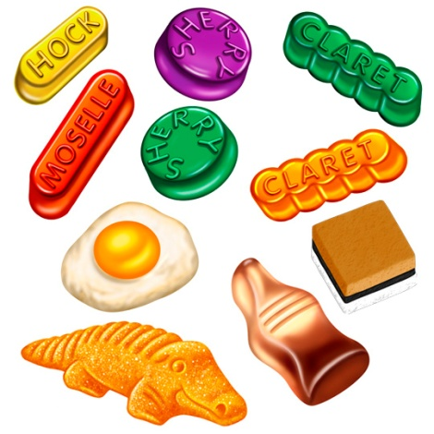

**10sweets ÷ 2 = 5sweets**

**OR  of 10 = 10 ÷ 2 = 5**

**To work out a quarter**

Split into four equal parts



** = **

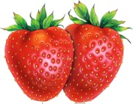****

**8 strawberries ÷ 4 = 2 strawberries**

**OR  of 8 = 8 ÷ 4 = 2**

**2/17 Units of measure**

**METRIC units of length are**:

Millimetre (mm)

Centimetre (cm)

Metre (m)

Kilometre (km)

2cm = 20mm 4.5cm = 45mm

1cm = 10mm

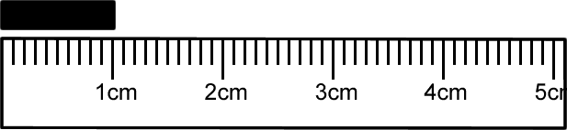

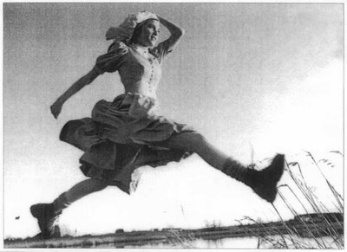

* A big stride is about a metre

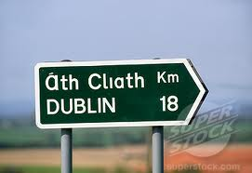

* Distance to Dublin is measured in kilometres

**METRIC units of mass are:**

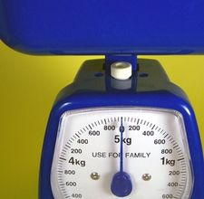Gram (g)

Kilogram (kg)

1 kilogram(kg) = 1000grams(g)

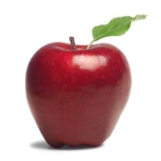

* An apple weighs 150grams

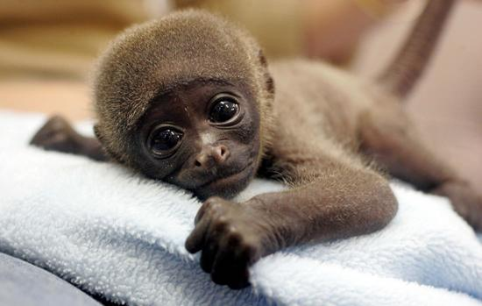

* Baby chimp weighs 3kg

**2/17 Units of measure (continued)**

**METRIC units of capacity (liquids) are:**

Millilitre (ml)

Centilitre (cl)

Litre (l)

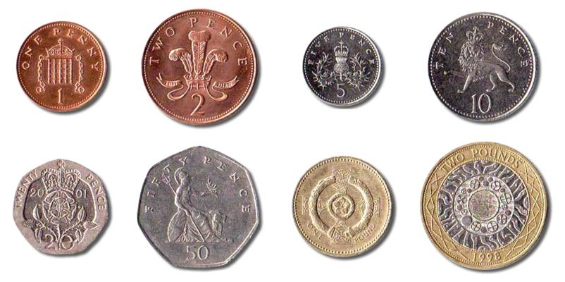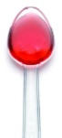

* A medicine spoon holds 5ml



* A 5-litre bucket
* Fuel for the car is measured in litres



**2/18 Compare units of measure**

**Think of the units of mass then order:**

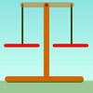

a bar of chocolate

your teacher

a blown-up balloon

a loaf of bread

A blown-up balloon **<** a bar of chocolate **<** a loaf of bread **<** your teacher

**Think of the units of length used then order:**

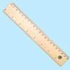

How high you could jump in the air

How far you can kick a football

How far you can run in ½ minute

Length of a bug

Length of a bug < you could jump in the air < you can kick a football < you can run in half a minute

**2/19 Money**

To write amounts of money

£3 or £3.00

50p or £0.50

£3.50 or 350p **BUT never £3.50p or £3.5**

**Value of coins**

1p or £0.01 2p or £0.02 5p or £0.05 10p or £0.10

20p or £0.20 50p or £0.50 £1 or £1.00 £2 or £2.00

**2/20 Bills and change**

To add amounts of money

24p + 32p

=20p + 4p + 30p + 2p

=20p + 30p + 4p + 2p

=50p + 6p

=56p

To find change from £1

Add-on method

56p **+ 4p** = 60p

60p **+ 40p** = £1

= **4p + 40p**

= **44p**

Subtraction method

£1 – 56p

= £1 – 50p – 6p

= 50p – 6p

= 44p

**2/21 Sequence of time**

60

60

24

7

4

12

Smallest Second(s)

Minute(min)

Hour(h)

Day

Week

Month

Largest Year

**2/22 Write time**

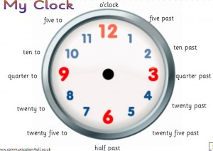

**The time shown is:**

**5 past 6 OR 6:05**

**2/23 2D shapes**

* 3 sides – Triangles

A vertical line of symmetry

equilateral isosceles

* 4 sides - Quadrilaterals

rectangle square parallelogram

trapezium kite rhombus

**2/24 3D shapes**

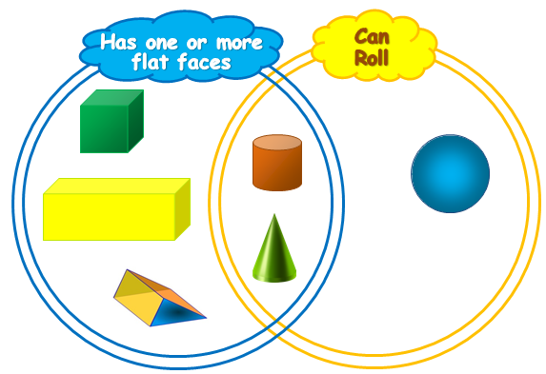

**cube cylinder cuboid**

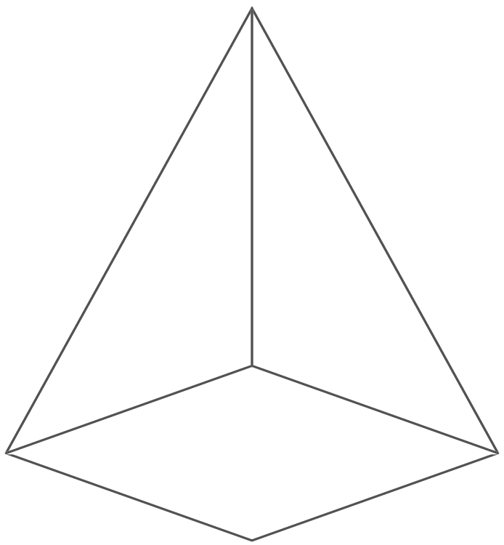

**pyramid sphere**

**corner edge face**

**2/25 2D shapes on 3D shapes**

6 6 faces – all rectangles

5 faces – 2 triangles

- 3 rectangles

3 faces – 2 circles

- 1 curved surface

2 faces – 1 circle

- 1 curved surface

5 faces – 1 rectangle

- 4 triangles

**2/26 To sort 2D shapes and 3D shapes**

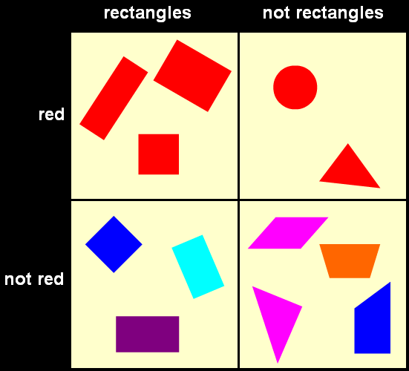

Carroll

diagram

Venn

diagram

**2/27 Sequence of shapes**

Make these shapes into a pattern

**2/28 Describe position, direction &**

**movement**

LEFT RIGHT

ANTICLOCKWISE CLOCKWISE

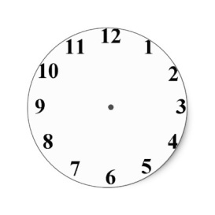

Clockwise (1 right angle)

or ¼ turn



Anticlockwise(1 right angle) or ¼ turn



Half turn (2 right angles)

**2/29 Tables and graphs**

Pictogram of

Year 2 favourite fruits

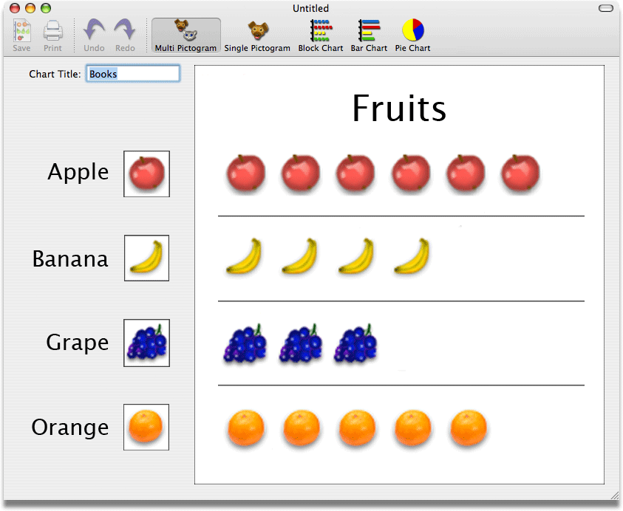

Tally chart showing animals in the zoo

|  |  |  |
| --- | --- | --- |
| Animal | Tally | Number of animals |
| Penguin | llll | 4 |
| Lion | lll | 3 |
| Snake | llll l | 6 |
| Giraffe | ll | 2 |
| Monkey | llll ll | 7 |

Block graph to show animals in the zoo

|  |  |  |  |  |  |
| --- | --- | --- | --- | --- | --- |
| 7 |  |  |  |  |  |
| 6 |  |  |  |  |  |
| 5 |  |  |  |  |  |
| 4 |  |  |  |  |  |
| 3 |  |  |  |  |  |
| 2 |  |  |  |  |  |
| 1 |  |  |  |  |  |
|  |  |  |  |  |  |

**2/30 Questions about tables and graphs**

Example:

Questions about ‘Animals in the zoo’

1. How many animals are there altogether?

4+3+6+2+7=22

1. How many more monkeys are there than lions?

7-3=4

1. What animal is there least of?

giraffe