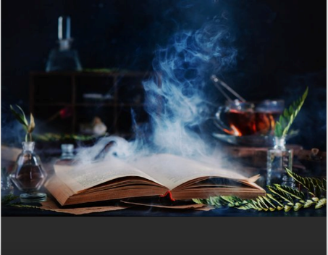
Harry Potter and the science of the properties of materials and reversible/ irreversible changes - Family Fact Sheet – Year 5

New vocabulary to learn to spell and to know the meaning | reversible | You can get the materials / chemicals back that you started with.
 | irreversible | You can not get back the materials / chemicals that you started with.
 | classifying | To groups things based on a criteria (e.g. magnetic / not magnetic)
 | property of ... | Characteristics of a material (eg. magnetic, toughness, electrical conductor, dissolves in water etc.)
 | filtering | Pass a liquid through something (ie a sieve) to remove a material from it.
 | fair test | A science investigation where only one variable (something that could be different) is changed
 | solution | A liquid mixture in which something else is dissolved in it or suspended in it.
 | evaporation | When a liquid turns to gas (think pan of water steaming on the cooker).
 | Condensation | When a gas turns into a liquid (think bathroom mirror).
 | viscous | Describes how ‘thick / gloopy’ a liquid is (think honey is very viscous, water is not very viscous).
 | dissolved | A solid chemically joins and becomes part of the liquid
 | suspension | Solid material is spread out equally within a liquid but does not join with it.

This BBC bitesize site is helpful for this. There are some extracts from the web page below.
What are irreversible changes? - BBC Bitesize. Read the text then consider the pictures – which are reversible and which are irreversible.

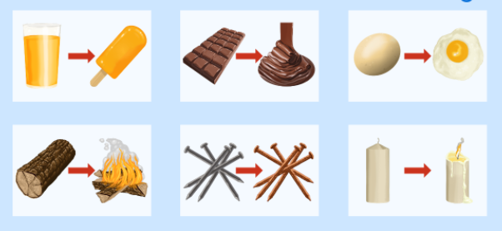

Irreversible changes:

In an irreversible change you cannotget back what you started with. New materials are always formed. Sometimes these new materials are useful to us.

Heating: Heating can cause an irreversible change. For example you heat a raw egg to cook it. The cooked egg cannot be changed back to a raw egg again.

Mixing: Mixing substances can cause an irreversible change. For example, when vinegar and bicarbonate of soda are mixed, the mixture changes and lots of bubbles of carbon dioxide are made. These bubbles and the liquid mixture left behind, cannot be turned back into vinegar and bicarbonate of soda again.

Burning: Burning is an example of an irreversible change. When you burn wood you get ash and smoke. You cannot change the ash and smoke back to wood again.

Reversible changes
A reversible change is a change that can be undone or reversed. If you can get back the substances you started the reaction with, that's a reversible reaction.
A reversible change might change how a material looks or feels, but it doesn't create new materials.
Examples of reversible reactions include dissolving, evaporation, melting and freezing.

Science investigations and fiar testing. | During our science work we pose and answer a number of questiond.  We make educated and informed guesses about what we think may happen – we call these predictions.  When testing a question we think carefully so we only change one ‘thing’, one variable – this make it a fair test.  These are some of the questions we may be asking:  - Which materials will dissolve in water?  - How can you separate a mixture of materials? What could help us?  - How could you make them dissolve more quickly? (eg. temperature of water, quantity of water, stirring or not stirring …..)

Characterisation and Harry Potter | 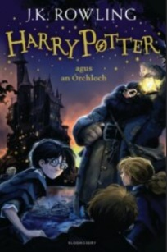  In Literacy we read a great number of extracts from the first Harry Potter book, which is called Harry Potter and the Philosopher’s Stone. However we do not read the whole text in school.  Could you challenge yourself to read this excellent chapter book?  Or perhaps someone older could read it to you?  Or you even listen to it as an audio book on your computer or tablet.

