Reception – Autumn 1 – Space
Key Words | Definitions
astronaut | 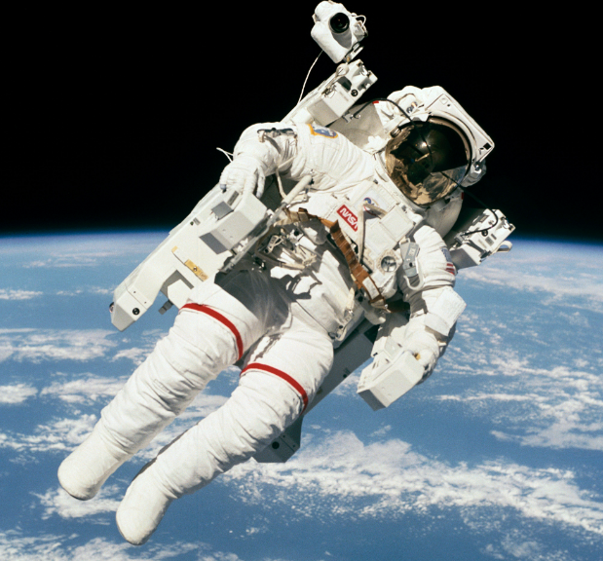
moon | 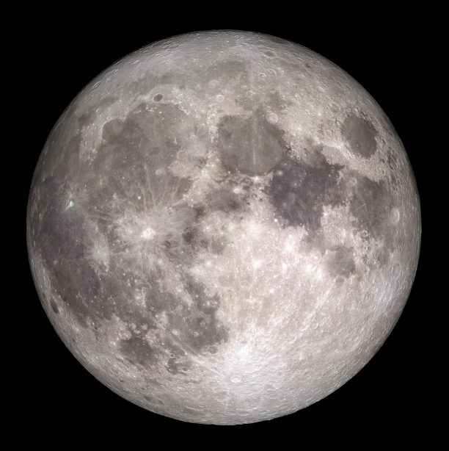
rocket / space shuttle | 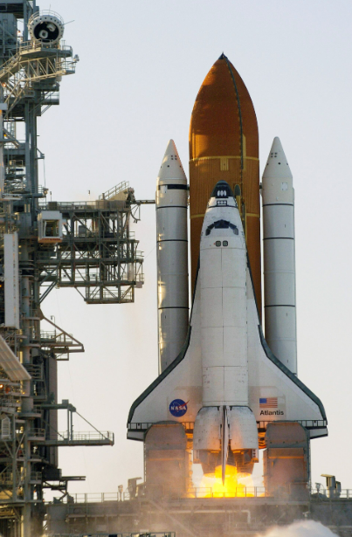
space boots | 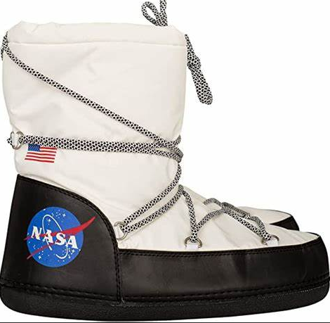
space helmet | 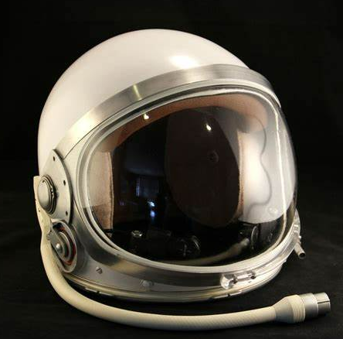
stars | 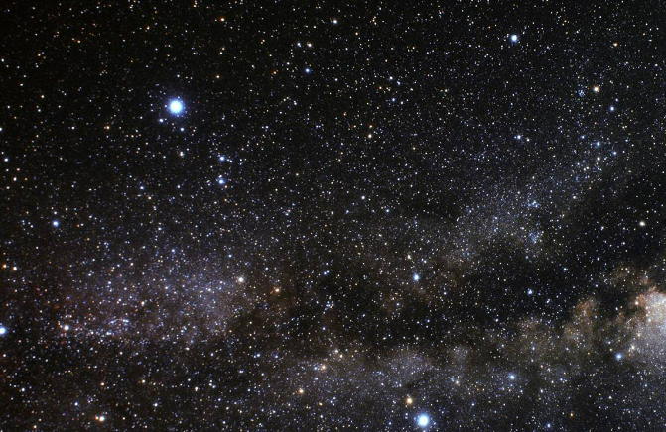
What is outer space?
Outer space is the part of space that is far away from Earth. Outer space is dark. There are many stars in space. The sun is a star. There are planets in space.

Whatever Next?
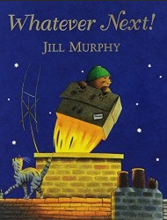  Watch the story of Whatever Next by scanning the QR code. | 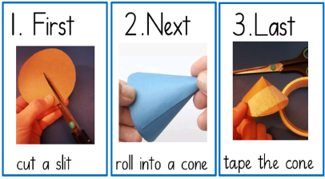  Make your own 3D rocket. | 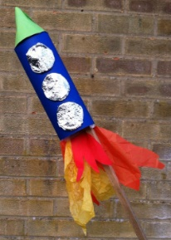  Take off into space!  “5, 4, 3, 2, 1, blast off!”

Important figures
Astronaut – A person who travels into outer space | Astronomer – A scientist who studies space
Tim Peake | Maggie Aderin-Pocock
Tim Peake is a British astronaut who was the first astronaut from Britain to visit the International space station in 2016.  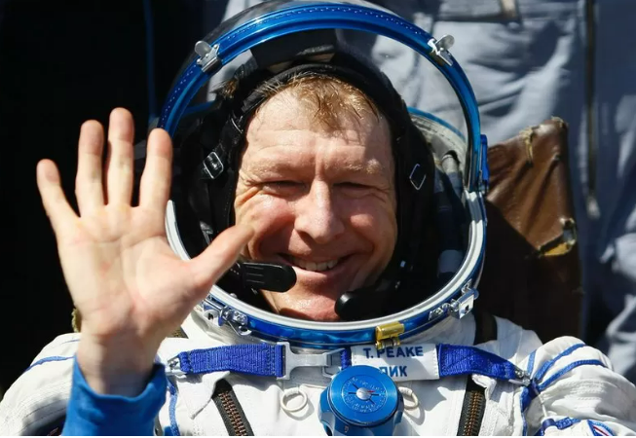 | Maggie is a British space scientist who has worked on telescopes and satellite systems.  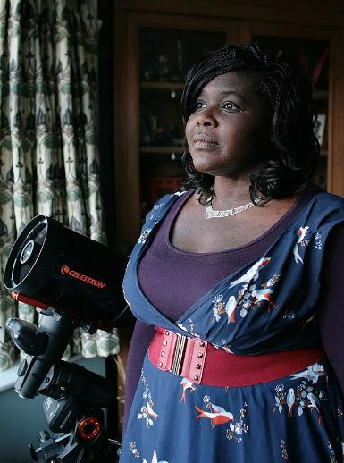

Monday | Tuesday | Wednesday | Thursday | Friday
Read with your child and sign their diary | Read with your child and sign their diary | Read with your child and sign their diary | Read with your child and sign their diary | Read with your child and sign their diary
Key Dates:
- Week 1 – Staggered intake. Please see your individual letter.

