Fantastic Mr Fox Family Fact Sheet – Year 2
Habitats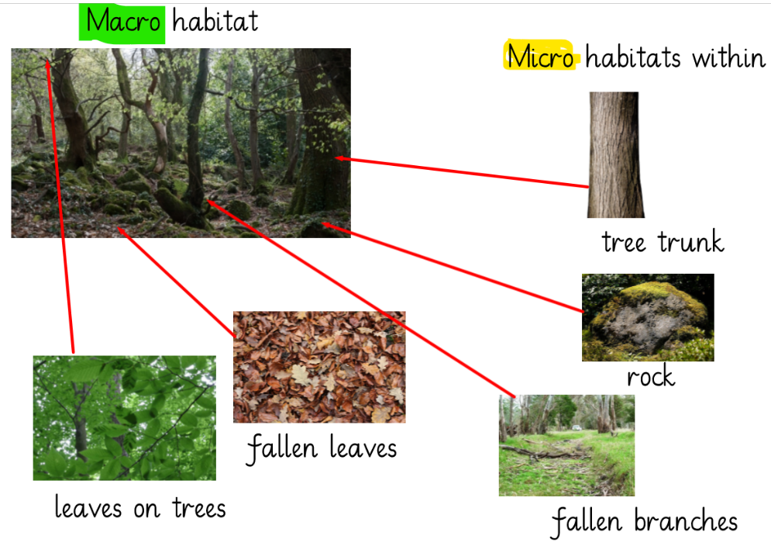 |  |  | Life cycle of the fox  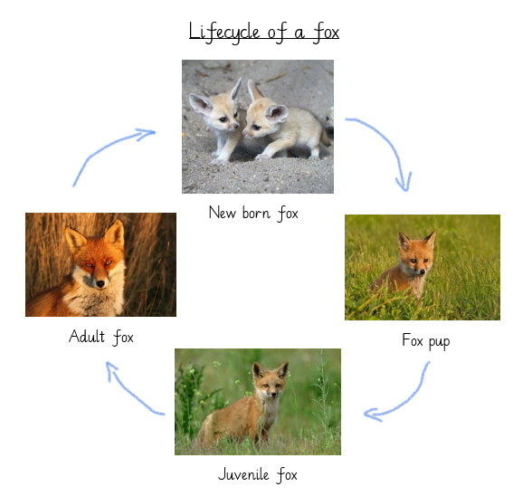
David Attenborough  Born: 1926-present  Job: an English broadcaster, writer, and naturalist | 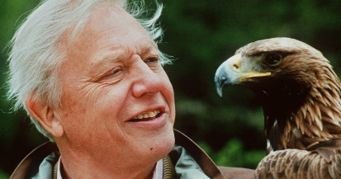 |  | Facts:  If Sir Attenborough could be any animal, he would be a sloth.  He has come face to face with a mountain gorilla.  There are at least 18 plants and animal named after him.
Y2 Important dates:  17th April – Woodlands Day with Fantastic Mr Fox  19th April – Spelling Bee 1st round (class level)  18th May – Spelling Bee 2nd round (school level) |  | The days our school will be closed:  21st April (training day)  1st May (May Bank Holiday)  8th May – Coronation Day

