Ancient Greeks Family Fact Sheet – Year 6
When did the Ancient Greeks exist?  About 2,500 years ago, Greece was one of the most important places in the ancient world. The Greeks were great thinkers, warriors, writers, actors, athletes, artists, architects and politicians.  The Greeks called themselves Hellenes and their land was Hellas. The name ‘Greeks’ was given to the people of Greece later by the Romans. | They lived in mainland Greece and the Greek islands, but also in colonies scattered around the Mediterranean Sea. There were Greeks in Italy, Sicily, Turkey, North Africa, and as far west as France.  They sailed the sea to trade and find new lands. The Greeks took their ideas with them and they started a way of life that's similar to the one we have today.
What have we learnt from them?  It is amazing, if not surprising, to discover just how much of today’s Britain have their origins in Ancient Greek society. The arts, sports, medicine, law, language, science, mathematics, philosophy, buildings and even some inventions, have all been greatly influenced by the Ancient Greeks.  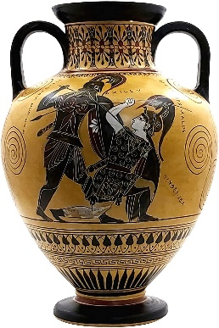 | How do we know about the Ancient Greeks?  We know much about the Ancient Greeks from objects which have survived for thousands of years. Archaeologists have dug up Ancient Greek artifacts and buildings and marine archaeologists have found wrecks of Ancient Greek ships and their cargoes.  Pottery has been the most useful find because it was often decorated with scenes of everyday life. We could work out what life was like by studying the pictures on the pots.  The Romans liked the buildings, statues and paintings of the Ancient Greeks and copied them. Some of these have survived.
What/who did they believe in?  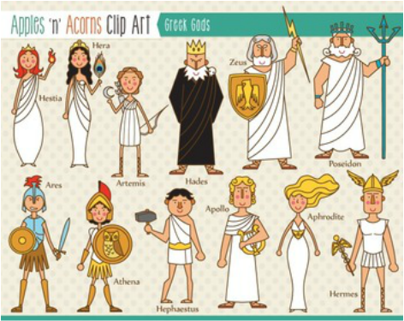 | The Greeks believed that gods and goddesses watched over them.  These gods were a bit like humans, but they lived forever and were much more powerful. They felt human emotions, like love, anger and jealousy, and they did not always behave themselves.  The Greeks thought the gods lived high above Mount Olympus, in a palace in the clouds. From here, they kept an eye on life below. From time to time, they would interfere in what was going on. They could send storms if they were angry and decide who was victorious in wars. Sometimes they even played tricks on humans too.
PE days: Palm Mondays and Tuesdays, Pine and Poplar Tuesdays and Fridays
Year 6 homework: Reading every night please.
Monday | Tuesday | Wednesday | Thursday | Friday
Maths book |  | Grammar book | Weekly Skills | Spellings
Year 6 Dates for Spring 2:
2nd March – World Book Day
Wk beg Mon 13th March – Mock SATs Week
Wk beg Mon 20th March – Ancient Greece Forest Days (day to be confirmed)

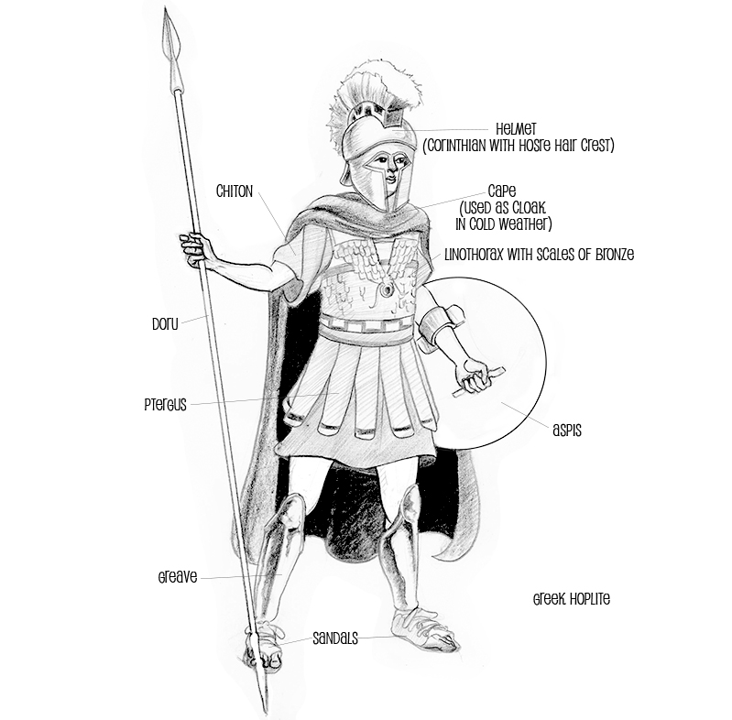
Ancient Greek Warrior

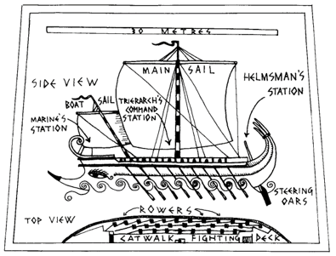
Ancient Greek Warship

