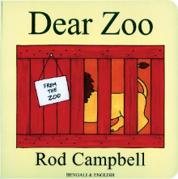
Dear Zoo by Rod Campbell

https://youtu.be/ZqGYWRHOV6E
Dear Parents, please help your child to name the animal from the story. There is a link to YouTube to watch and listen to the story. Ask your child to point out and name the animals as you listen together. Ask: Which is your favourite animal?

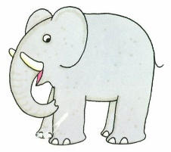  an elephant | 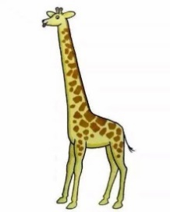  a giraffe | 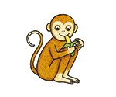  a monkey | 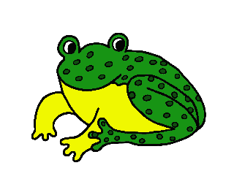  a frog
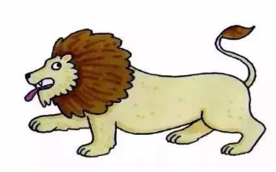  a lion | 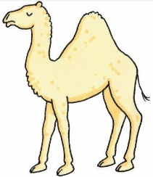  a camel | 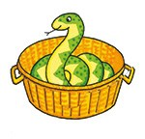  a snake | 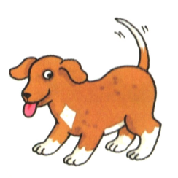  a dog
Some activities for you to do at home with your child:

-Ask your child to draw a picture of a pet they would like from the Dear Zoo story. Talk to your child about what they are drawing.

-Play a game with other members of your family. Take turns to make animal sounds. Who can guess the most animal sounds correctly?

