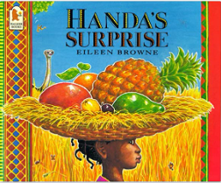
In art we will be learning about primary colours and the different shades they make. We will also be mixing our own paint to create light and dark shades. We will be using the techniques we have learnt to create a sunset savannah.
Listen to the story ‘Handa’s Surprise’ by scanning this code.

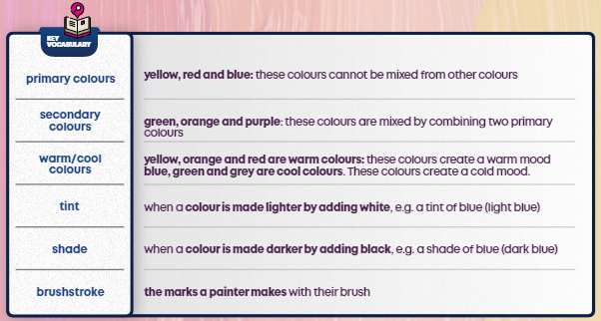

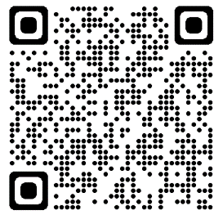

Handa puts some fruits in her basket to take to her friend Akeyo. But Handa’s walk takes her passed some animals and the fruits do look delicious!!

Year 1 dates for Spring 1:
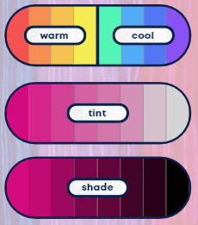
Mon 9th Jan – Aspiration Week
Year 1 PE Days:

Tuesday – Beech
Wednesday – Beech, Birch, Blackthorn
Friday – Birch, Blackthorn
Mon 6th Feb – Children’s Mental Health Week

Year 1 Homework – Reading every night please and practice your rainbow words!!

Monday | Tuesday | Wednesday | Thursday | Friday
- Reading books changed  - New spellings sent home |  |  | - Maths homework sent home | - Spelling test

